PowerFlow Toolset User Manual

Prepared by:

University of Illinois at Urbana-Champaign

Version:

Released:

Revision History

|  |  |  |
| --- | --- | --- |
| **Version Number** | **Date** | **Comments** |
| 1.0 |  | Original document |

Table of Contents

[Revision History ii](#_Toc388205939)

[Table of Contents iii](#_Toc388205940)

[Acronyms vi](#_Toc388205941)

[1. Toolset Development - 1 -](#_Toc388205942)

[1.1 Software - 1 -](#_Toc388205943)

[1.2 Hardware - 2 -](#_Toc388205944)

[2. Modeling Standards and Tools - 3 -](#_Toc388205945)

[2.1 Signal Routing and Naming - 3 -](#_Toc388205946)

[2.2 Modeling Definitions - 3 -](#_Toc388205947)

[2.3 Auxiliary Tools - 3 -](#_Toc388205948)

[2.3.1 PowerFlow Data Manager and Data Sink - 4 -](#_Toc388205949)

[2.3.2 Fluid and Component Properties - 4 -](#_Toc388205950)

[2.3.3 Electrical and Thermal Source/Sink - 4 -](#_Toc388205951)

[2.3.4 Unit Conversion - 5 -](#_Toc388205952)

[3. Mission Profile - 6 -](#_Toc388205953)

[4. System Architecture - 11 -](#_Toc388205954)

[4.1 Thermal Management System - 11 -](#_Toc388205955)

[4.2 Fuel and Oil Thermal Management System - 11 -](#_Toc388205956)

[4.3 Electrical Power System - 12 -](#_Toc388205957)

[4.4 Hydraulic Power System - 12 -](#_Toc388205958)

[5. Subsystem Modeling - 14 -](#_Toc388205959)

[5.1 Thermal Management System - 14 -](#_Toc388205960)

[5.1.1 Cabin - 14 -](#_Toc388205961)

[5.1.2 Heat Exchanger - 18 -](#_Toc388205962)

[5.1.3 Mixing Junction - 23 -](#_Toc388205963)

[5.1.4 Turbocharger - 26 -](#_Toc388205964)

[5.1.5 Valve - 30 -](#_Toc388205965)

[5.1.6 Fan - 33 -](#_Toc388205966)

[5.2 Fuel and Oil Thermal Management System - 36 -](#_Toc388205967)

[5.2.1 Fuel Tank - 36 -](#_Toc388205968)

[5.2.2 Fuel Pump - 41 -](#_Toc388205969)

[5.2.3 Oil Tank - 45 -](#_Toc388205970)

[5.2.4 Oil Pump - 45 -](#_Toc388205971)

[5.2.5 Air Cooled Oil Cooler - 45 -](#_Toc388205972)

[5.2.6 Stochastic Heat Loads - 48 -](#_Toc388205973)

[5.3 Electrical Power System - 50 -](#_Toc388205974)

[5.3.1 Generator - 50 -](#_Toc388205975)

[5.3.2 Exciter System - 53 -](#_Toc388205976)

[5.3.3 Generator System - 55 -](#_Toc388205977)

[5.3.4 Battery - 57 -](#_Toc388205978)

[5.3.5 Inverter - 60 -](#_Toc388205979)

[5.3.6 AC Loads - 61 -](#_Toc388205980)

[5.3.7 Transformer - 63 -](#_Toc388205981)

[5.3.8 Rectifier - 65 -](#_Toc388205982)

[5.4 Hydraulic Power System - 67 -](#_Toc388205983)

[5.4.1 Engine Driven Pump - 67 -](#_Toc388205984)

[5.4.2 Fluid Reservoir - 70 -](#_Toc388205985)

[5.4.3 Bypass Valve - 73 -](#_Toc388205986)

[5.4.4 Hydraulic Load - 73 -](#_Toc388205987)

[5.5 Auxiliary Loads and Systems - 74 -](#_Toc388205988)

[6. System Modeling - 76 -](#_Toc388205989)

[6.1 Engines System - 76 -](#_Toc388205990)

[6.1.1 Engine Output Signal - 76 -](#_Toc388205991)

[6.1.2 NPSS Model - 77 -](#_Toc388205992)

[6.2 Environment Control System - 78 -](#_Toc388205993)

[6.2.1 Overall System - 78 -](#_Toc388205994)

[6.2.2 PACK Components - 79 -](#_Toc388205995)

[6.3 Fuel and Oil System - 81 -](#_Toc388205996)

[6.3.1 Oil Tank and Pump Subsystem - 82 -](#_Toc388205997)

[6.3.2 Fuel Tank and Pump Subsystem - 82 -](#_Toc388205998)

[6.4 Electrical System - 83 -](#_Toc388205999)

[6.4.1 AC Subsystem - 84 -](#_Toc388206000)

[6.4.2 DC Subsystem - 85 -](#_Toc388206001)

[6.4.3 AC-DC Connections - 86 -](#_Toc388206002)

[6.5 Hydraulics System - 87 -](#_Toc388206003)

[7. References - 89 -](#_Toc388206004)

Acronyms

|  |  |
| --- | --- |
| Acronym | Meaning |
| ACM | Air Cycle Machine |
| APU | Auxiliary Power Unit |
| TMS | Thermal Management System |
| RAM | Random Access Memory |
| GUI | Graphical User Interface |
| FOCS | Fuel/Oil Cooling System |
| ECS | Environmental Control System |
| ACOC | Air Cooled Oil Cooler |
| DC | Direct Current |
| AC | Alternating Current |

# Toolset Development

Development goals for the Rolls-Royce PowerFlow toolset focused on the following nine key areas:

1. Multi-physics
   * capture dynamics in four primary energy domains: electrical, hydraulic, pneumatic, thermal
2. Modularity
   * adaptable interfaces with well-defined I/O that can easily be swapped in and out for different aircraft configurations
3. Multi-Fidelity
   * high fidelity plugins with tolerance to multiple levels of fidelity, stochastic simulation events, dialable resolution and accuracy
4. Scalability
   * extend, expand, and adapt to new platforms and system configurations
5. Static and dynamic
   * modules with static and/or dynamic demands allowing for steady-state or dynamic exploration
6. User-Interface
   * user friendly and intuitive components with written documentation that can be effectively used by a large population
7. Performance
   * require only workstation level of computational resources, computationally efficient, and execute at 3x real time
8. Software
   * ability to handle multiple time scales with efficiency, withstand updates in software and platforms, recyclable components and code, heavily documented with consistent interfaces and coding practices
9. Platform
   * capable of running on Windows/Simulink machines and interfacing with a variety of simulation tools, specifically Numerical Propulsion System Simulation (NPSS)

The following chapters of this user manual will address the first five topics at the system and component level. This user guide is to address the sixth topic. Portions of the final three topics will be discussed in the next two sections.

## Software

Version of the PowerFlow toolset has been developed and verified as functional with the following operating systems and software packages:

* Windows 7 and Windows 8.1
* MATLAB version 7.11.1 (2010b) with Service Pack 1
* Simulink version 7.6.1

All Simulink models use native Simulink blocks and require no additional libraries to be installed. The toolset has been tested for functionality in MATLAB 2014a without any issues.

## Hardware

Workstation level computers have been used for the development and execution of models using PowerFlow components. Components have been upgraded and modifications have been conducted to enable the models to run faster when integrated. Further details are included in the following chapters.

Benchmarks for version of the PowerFlow toolset were conducted on a workstation with the following configuration:

* Processor: Intel Xeon E31225 at 3.10GHz
* RAM: 8.00 GB
* System Type: 64-bit Operating System, x64-based processor
* Operating System: Windows 8.1
* MATLAB version: 32-bit MATLAB version 7.11.1 with SP1

A sample Boeing 737 model is used for benchmarks. Details regarding the development of this sample model is given in Chapter 6. Benchmark results for the sample model run with an NPSS engine model and run without the NPSS model are shown in Figure 1.1.

Figure 1.1. Execution Time Benchmarks for a Boeing 737 Sample Model

# Modeling Standards and Tools

With an extensive number of models that can be interconnected, a consistent naming convention and methodology is used to minimize integration time and potential modeling errors.

## Signal Routing and Naming

Each component that supports interconnections between components follows a bus structure format for routing signals. Signals are labeled to include the physical variable and appropriate units and follow the format of *variable\_unit*.

Table 2.1. Signal Naming of Variables and Units

|  |  |  |  |  |
| --- | --- | --- | --- | --- |
|  | **Variable** | **Signal Prefix** | **Units** | **Signal Suffix** |
| **Fluid Variables** | Mass Flow Rate | mdot | Kilograms per second | kgps |
| Temperature | temp | Kelvin | K |
| Pressure | pres | Kilopascals | kPa |
| Enthalpy | H | Kilojoules per kilogram | kJpkg |
| **Electro-mechanical variables** | Battery Voltage  Generator Voltage  Torque  Power Loss  Excitation current | VDC  vdq0  Torque  Ploss  Excit current | Volts  Volts  Newton-meter  Watts  Ampere | V  V  Nm  W  A |

## Modeling Definitions

A list of definitions for commonly used terms in the PowerFlow toolset:

1. System – a collection of interconnected subsystems that is considered a platform (B737, B787, Emb145, etc.).
2. Subsystem – a collection of units and components such as the ECS or FOS.
3. Unit – is composed of multiple components but is often packaged and sold as a single unit. An example of such a unit is the air conditioning PACKs.
4. Component – is a fundamental device that serves a purpose. Examples of components are tanks, pumps, batteries, and motors.
5. Parameter/Variable – describes a physical characteristic of a component or unit.
6. Signal – represents the interconnection and information flow between models. It can be used to describe physical, electrical, or digital information flow.

## Auxiliary Tools

The PowerFlow toolset contains a library of auxiliary tools that can be used to improve integration of components and systems. Several of these tools are already built into components and units, such as the sources and sinks. Others exist for the convenience of the user when building models from scratch or analyzing large models.

### PowerFlow Data Manager and Data Sink

The PowerFlow data manager and data sink blocks work together to help capture and record system data during simulation. The data sink block is located in all components. Each component sends a bus structure of signals to the data sink block that are then detected by the PowerFlow data manager.

The data manager provides a GUI for the user to select which signals should be tracked during the simulation. Figure 2.1 shows an example of the GUI. The list of signals that can be logged is featured on the left, signals that will be logged are on the right, add/remove and apply buttons are below the selected signal dialogue. The drop down menu below the *Apply & Exit* button allows the user to select the output format of the signals as a bus or mux signal.

|  |
| --- |
|  |
| Figure 2.1. PowerFlow Data Manager GUI |

### Fluid and Component Properties

The fluid and component properties block is responsible for specifying and loading property tables into the MATLAB workspace. The GUI allows for the specification of fuel, oil, and air fluid properties, as well as pump, fan, compressor, and heat exchanger component properties. All property tables are loaded into the MATLAB workspace prior to simulation of the model where the block is located.

### Electrical and Thermal Source/Sink

The sink and source blocks for electrical and thermal loads allows for easy tracking of loads throughout the aircraft. When a component calculates a required electrical power, that signal can be sent to an electrical sink. The electrical source block tracks all electrical sinks in the model and aggregates the load for the electrical system. Each block has a location selection so that loads can be tracked by their location in the aircraft. For components that generate heat due to inefficiency, a thermal sink is used. The thermal source block will aggregate all of the thermal loads in the model so that they can be handled appropriately.

|  |  |
| --- | --- |
|  |  |
| Figure 2.2. Electrical Sink GUI | Figure 2.3. Electrical Source GUI |
|  |  |
| Figure 2.4. Thermal Sink GUI | Figure 2.5. Thermal Source GUI |

### Unit Conversion

A unit conversion block allows the user to convert units of mass, density, energy, power, force, temperature, pressure, length, area, volume, velocity, volumetric flow rate, and mass flow rate. Conversion is supported between common units in metric and imperial measurement systems.

# Mission Profile

## Walkthrough or Express

The PowerFlow toolset is a complex tool in which all users may not know how to use while some others may be experienced and can use the tool well. For that reason, the PowerFlow GUI now opens up with a screen where the user can choose whether to go through the Express mode where all the mission profile building is done through a single interface or a walkthrough mode where the interfaces walk the user through the process. The screen can be seen in the figure below.

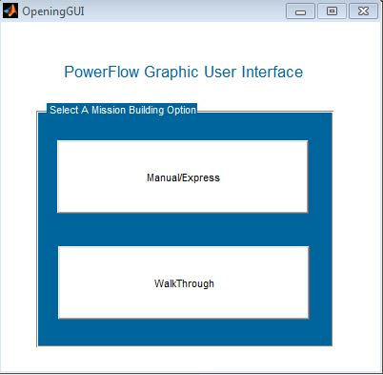

Figure .. Opening GUI

## Walkthrough GUI Express

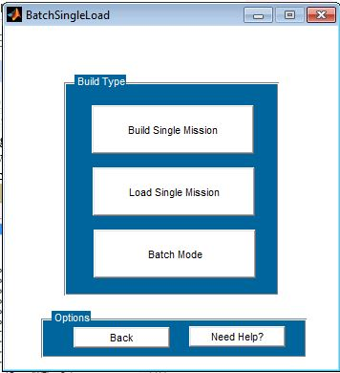

Figure . Choose Build Single Mission, Load Single Mission, or Batch Mode

Once the user selects the walkthrough option the figure above is shown. If the user select “Load Single Mission” then after loading the user is automatically brought to the analyze interface. The Batch Mode is the same as the Batch Mode that will be described in more detail later in the manual. If a user selects “Build Single Mission” the interfaces below are used in a step by step process to lead the user through building a mission without any mistakes. For each interface a Help button is added in order to lead the user through what to do at each screen in case of confusion.

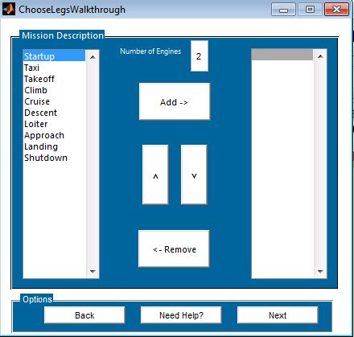

Figure . Choose mission legs

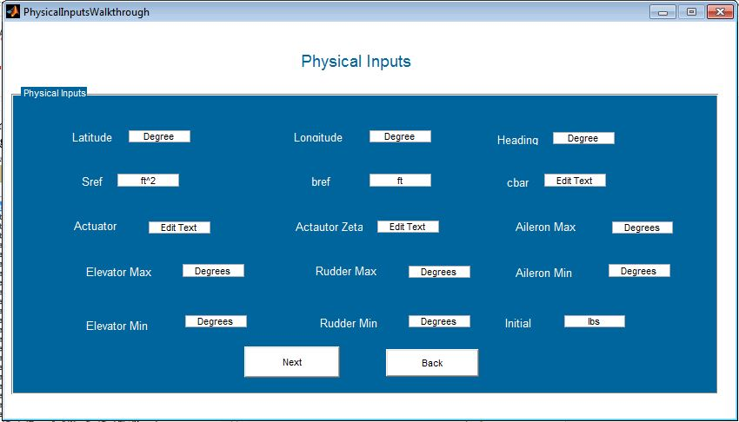

Figure . Physical inputs for aircraft.

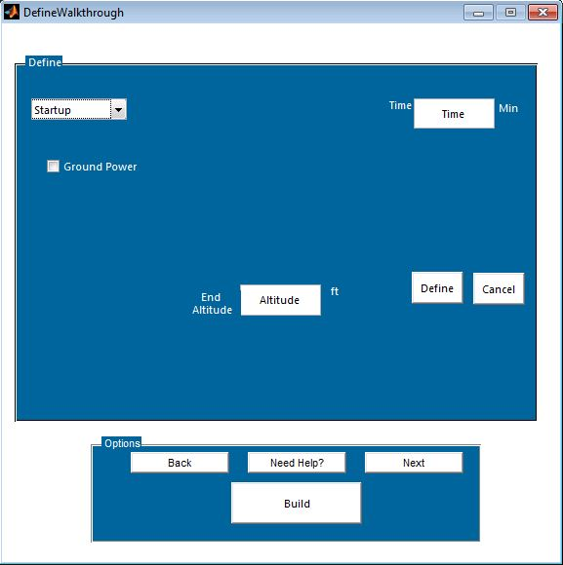

Figure . Define parameters for the mission legs

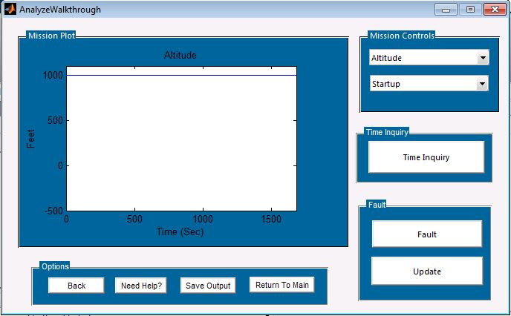

Figure . Analyze Mission

## Mission Profile GUI Express

Figure 3.1 shows the Mission Profile GUI that the user sees upon opening the program. Figure 3.2 shows the Mission Profile GUI labeled with numbers.

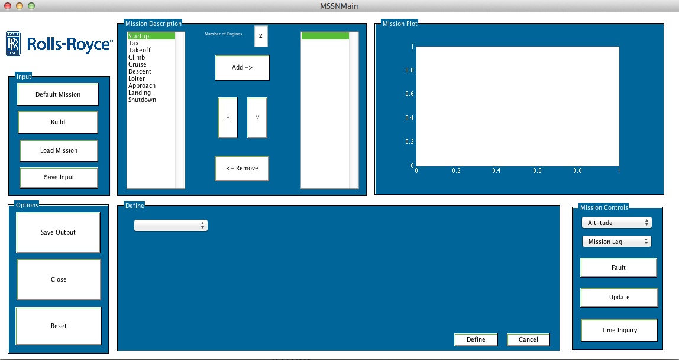

Figure 3.1. Main GUI

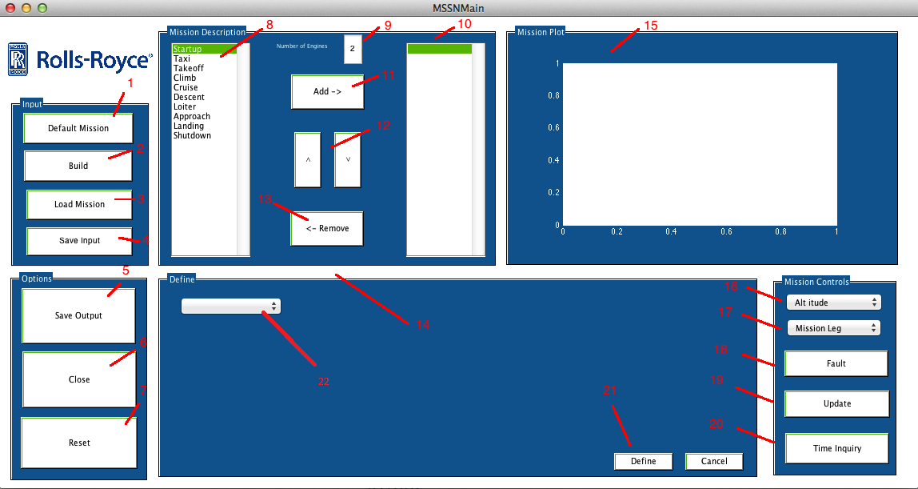

Figure 3.2. Main GUI Labeled

[1] Default Mission – Loads a Default mission and prepares the mission to be built by Build (refer to [2]).

[2] Build – Builds the mission.

[3] Load Mission –Loads a user made mission that has been saved using Save Output (refer to [4]).

[4] Save Input – Saves mission inputs after the user has defined all mission phases.

[5] Save Output – Saves the mission profile after the mission has been built using build (refer to [2]).

[6] Close – Closes the program.

[7] Reset – Resets the program and clears mission profile.

[8] Phase List Box – A list box of the available mission phase options. These can be picked one at a time or several at a time.

[9] Number of Engines- Defines the number of engines the aircraft will have.

[10] Mission List- A list box of the selected phases from the Phase List Box (refer to [8]) that will be defined in the mission profile.

[11] Add- Adds the selected mission phases in Phase List Box (refer to [8]) into the Mission List Box (refer to [10]).

[12] Up and Down – Relists the mission phases within the Mission List Box (refer to [12]).

[13] Remove – Remove the selected mission phases within the Mission List Box (refer to [13]).

[14] Define Container – The area in which the inputs are visible given the selected mission phase inside the Define List drop down menu (refer to [22]).

[15] Mission Plot – Plots the mission profile.

[16] Mission Property drop down menu – Drop down menu to select the mission property the user would like to be shown in the Mission Plot (refer to [15]).

[17] Mission Leg drop down menu – Drop down menu to select the mission phase the user would like the Mission plot to zoom to (refer to [15]).

[18] Fault- Initializes the Fault GUI that allows the user to insert a failure to either the engines or generators.

[19] Update- Updates the Mission Plot. This must be pressed after inserting a fault.

[20] Time Inquiry- Initializes the Mission Analyze GUI. The Mission Analyze GUI allows the user to access all the mission characteristics at any given time.

[21] Define- Defines the mission phase properties after the mission phase has been selected in the Define List drop down menu (refer to [22]) and all properties have been input into the Define Container (refer to [14]).

[22] Define drop down menu- Menu that allows the user to select which mission phase to define. Once the phase has been selected, options will become visible within the Define container (refer to [14]).

[23] Physical Input – Opens up GUI where user defines the physical properties of aircraft.

## Fault GUI and Fault Emergency Landing GUI

### GUI Layout

Adding a fault within a mission profile means that the user desires to model an engine or generator failure. This can be done by pressing the Fault button [18] after a mission profile has been built. The layout for the Fault GUI can be seen below in figure 3.3 and 3.4.

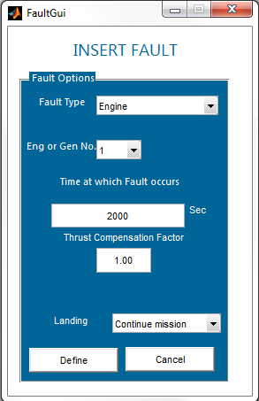

Figure 3.3. Fault GUI

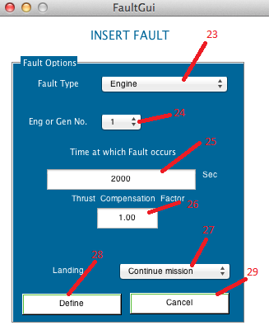

Figure 3.3. Fault GUI labeled

[23] Fault Type – Specifies whether the fault was an engine or generator fault.

[24] Engine or Generator Selection- Select which engine or generator the fault occurs.

[25] Fault time- Input to choose when fault occurs.

[26] Thrust compensation- Amount of thrust compensation the other engines commit to due to failure.

[27] Landing Selection- Select whether to “Continue Mission” or “Land”.

[28] Defines the fault. If Landing Selection [27] is set to “Continue Mission” then user will be directed to Mission Profile GUI. If [27] is set to “Land’ then user will be directed to Fault Emergency Landing GUI.

### Inserting a fault

In order for the user to set a fault, a mission must have been previously built. The user can then initialize the Fault GUI by pressing Fault [18]. The user then has several options to describe the type of fault: the type of fault [23], if the fault is an engine or generator fault [24], the time at which the fault occurs [25], the thrust compensation [26], and if the mission continues or if the aircraft must make an emergency landing [27]. If Landing Selection [27] is set to “Continue Mission” then user will be directed to Mission Profile GUI. If [27] is set to “Land’ then user will be directed to the Fault Emergency Landing GUI. The Fault Emergency Landing GUI is displayed below in figure 3.4. After defining the fault in both cases it is important for the user to press Update [19] in order to have the results displayed in the mission plot [15]. A diagram is shown in figure 3.5 to visualize the fault process.

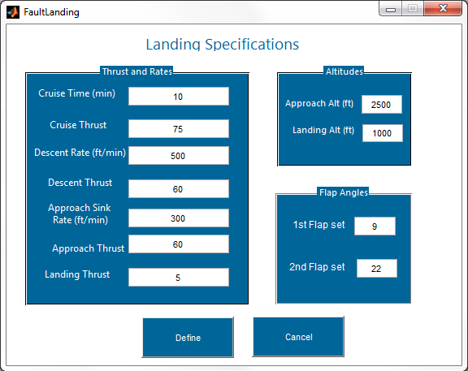

Figure 3.4. Fault Emergency Landing GUI

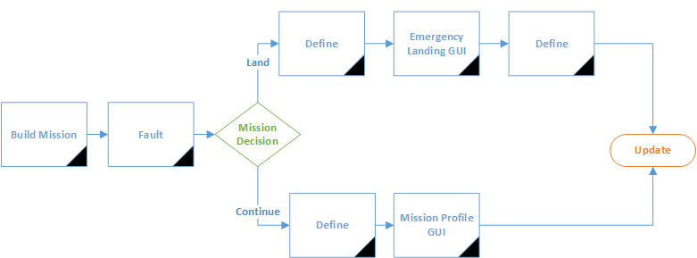

Figure 3.5. Fault Process Diagram

## Mission Analyze GUI

Mission analyzation is quite simple. Once a mission has been built, the user can click on the Time Inquiry Button [20]. This initializes the Mission Analyze GUI that can be seen in the figure below.

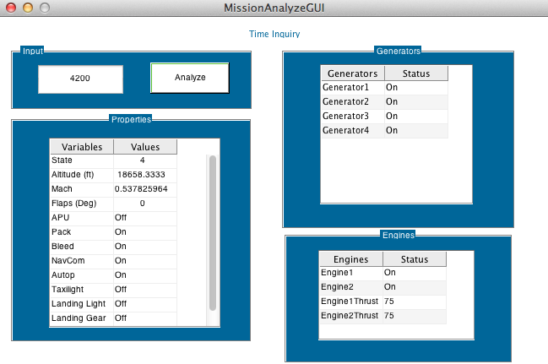

Figure 3.6. Mission Analyze GUI

Once the GUI is open, the user simply inputs the desired time and the GUI will display all of the mission properties at that given time.

## Mission Profile Building

The user has the option to load a default mission using [1], in which the program comes with, load a previously made mission using [3], or build a mission. After completed any of these three options the user must then select Build [2].

Mission profiles determine the type of mission the engine would experience. This includes time scheduled variables, such as atmospheric conditions and mission phase. For a custom mission the user defines a set of the previous mission phase that are consistent with the desired mission or segment of a mission. The individual mission phases for a standard mission are described below.

Table 3.1. Mission Leg Descriptions

|  |  |  |
| --- | --- | --- |
| Start-up | 1 | This includes the APU running the systems while docked at the gate |
| Taxi | 2 | Describes aircraft states from gate to runway |
| Takeoff | 3 | Shows aircrafts states during the takeoff run |
| Climb | 4 | Describes aircraft states immediately after takeoff until cruise. Or from one phase to another phase at a higher altitude (ex: Loiter 🡪 Climb 🡪 Cruise) |
| Cruise | 5 | Shows aircraft states in sustained level flight |
| Descent | 6 | Describes aircraft states from one phase to another phase at a lower altitude (ex: Cruise 🡪 Descent 🡪 Loiter) |
| Loiter | 7 | Shows aircraft states in sustained flight at lower altitude usually before approach |
| Approach | 8 | Describes the aircraft states in the time just before landing |
| Landing | 9 | Shows aircrafts states during the landing run |
| Taxi | 2 | Describes aircraft states from runway to gate |
| Shutdown | 10 | This includes the APU running the systems while docked at the gate |

For a user to build a unique mission, the user must first select the mission phases that will be used within the desired mission profile. This is done by selecting the desired mission phases from the Phase List Box [8] and add [11] to the Mission List Box [10]. The mission phases occur in sequence within the Mission List Box and thus can be rearranged using the Up and Down options [12]. Once the mission phases have been selected they will appear in the Define List Menu [22]. The user must select each phase and define the inputs that appear within the Define container [14] and click Define [21] for each mission phase. Once all mission phases have been defined then the user can build the mission by pressing Build [2]. Figure 3.3 gives a visual representation of the mission building process.

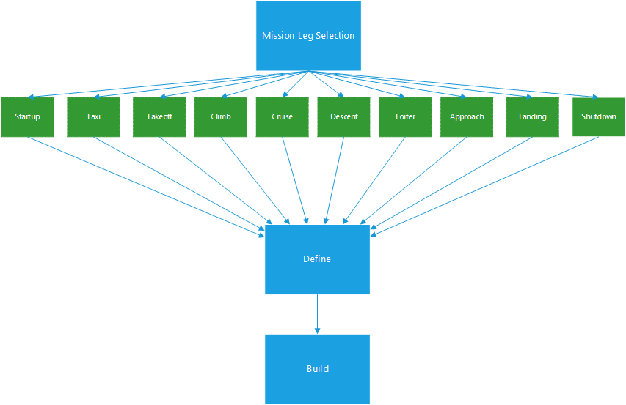

Figure 3.7. Mission Profile Build Diagram

The mission profile function generates a structured variable with six categories these categories are shown below in figure. This structured variables only report when a change in a variable occurred in time. This reduces the data size and made the data easier to use. Each phase function builds a structured variable for each desired phase. When each phase function has run, a separate function is run to concatenate the structured variables from each phase function. A breakdown of the output structure is shown in Figure 3.4.

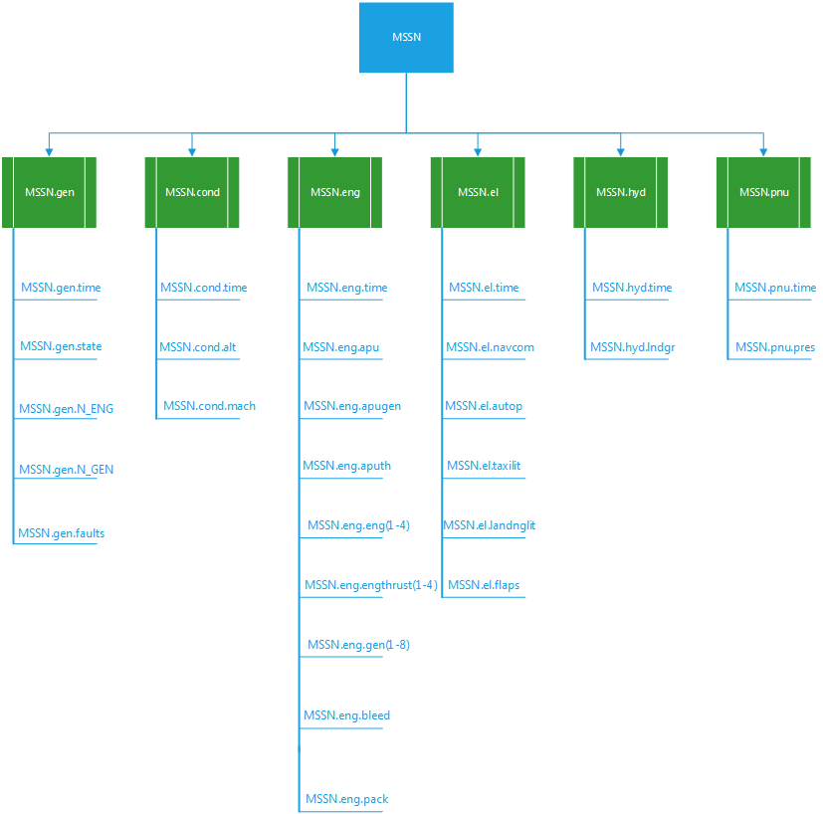

Figure 3.8. Output structure diagram

Once this structure has been built and modified in a way in which is desired by the user, the MSSN structure variable is sent to a Simulink block for each variable to be sent as a signal to the parts of the model. The model below does not yet utilize all the variables in the mission profile. The atmospheric conditions are determined by using a standard atmosphere approximation from the given altitude and then allowing for an offset to be applied to the signal. The signals read the data from the MSSN variable through the use of look-up table that use linear interpolation for some variable, such as altitude, and step input tables for on/off switch variables like landing lights.

The physical inputs for the aircraft are needed to be added before the mission to be built. These values are pending to change based on the necessary paramters required by the simulink model. These are currently not in use but are anticipated to be in use in future versions.



Figure . Physical Inputs

*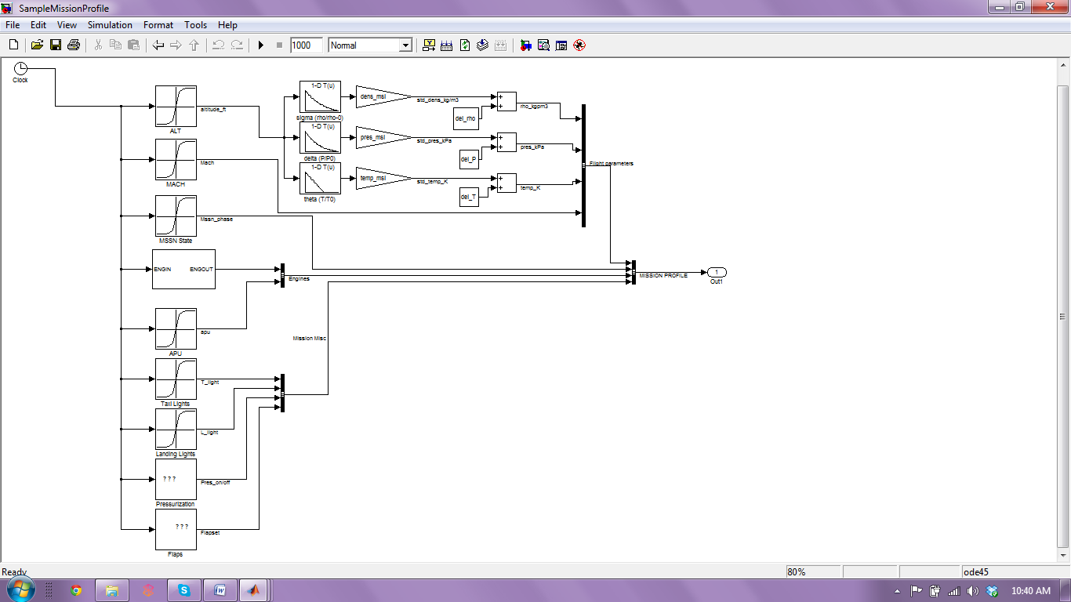*

Figure 3.9. Simulink model

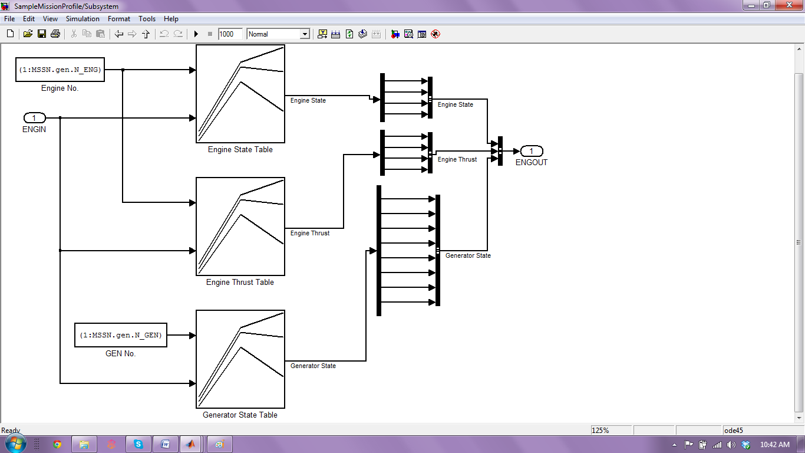

Figure 3.10. Zoomed in view of engines model block

The code works by taking the inputs of the user through the GUI and passing them to a Main function that calls individual sub-functions that correspond to the mission phases. Then a concatenation function combines the individual sub-function outputs into one variable that is the output. The graphic below shows the general process.

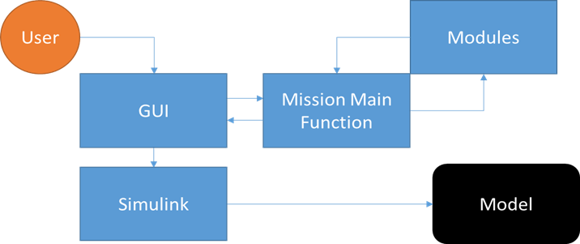

Figure 3.11. Overall functionality diagram

# System Architecture

## Thermal Management System

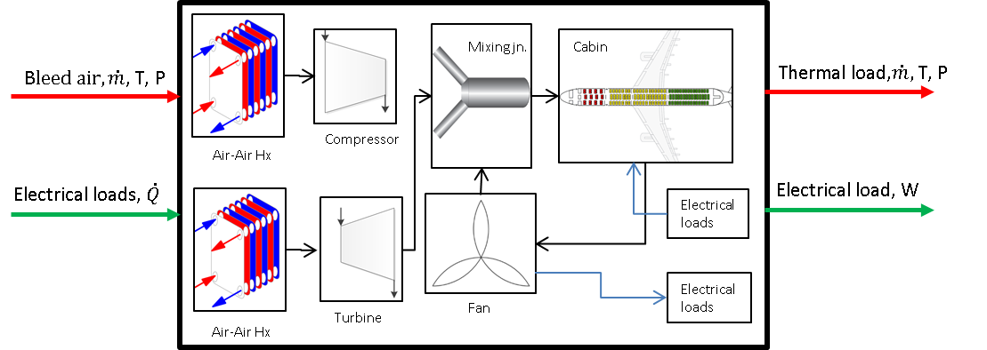

Figure .. Thermal Management System Diagram

The thermal management system contains air-air heat exchangers, bleed valves, turbine-compressor (turbocharger), 1-D passenger cabin model, re-circulation fans and mixing junctions. The purpose of the thermal management system is to model the environmental control system (ECS) in aircrafts (The PACKS are essentially air-cycle machines). The models have the capability to be scaled/ modified according to different aircraft component specifications through GUI interface and performance maps. Some of the components (fans, cabin) are linked to the electrical system through thermal/electrical sinks and sources.

## Fuel and Oil Thermal Management System

The fuel thermal management system contains tanks, pumps, and heat exchangers to move heat from one fluid to another. The fuel system supplies fuel to the engine in addition to acting as a thermal sink for heat loads. Recirculated engine fuel can be dumped back into the tanks where the time varying mass and temperature are tracked. A similar configuration can be achieved with the oil system. Additionally, all AC driven pumps send their electrical loads to the electrical power system.

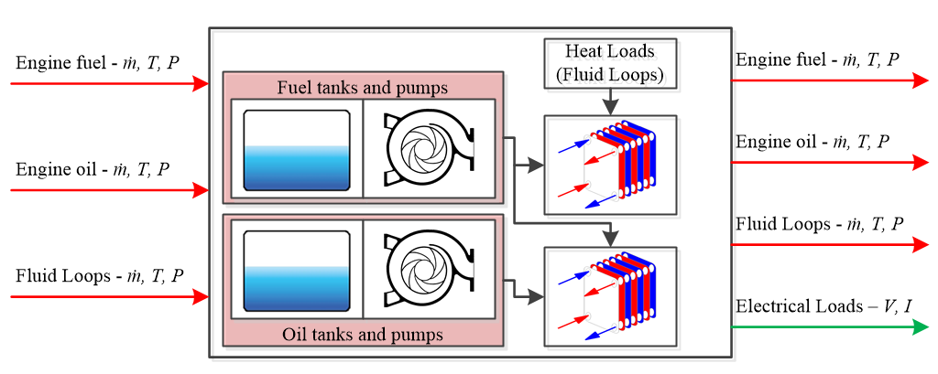

Figure 4.2. Fuel and Oil Thermal Management Diagram

## Electrical Power System

The electrical power system contains the exciter/generator and dc power systems connected to the electrical distribution system, which interfaces the 28V dc bus, 115V ac bus and provides power to the fans, actuators and other generic loads. Each component has power loss models interfacing with ECS to track the total rejected heat within the aircraft thermal model. Engine models provide the low-pressure spool speed and APU speeds and receive the load torque from the generators. Electrical pumps, actuators and other generic loads can be based on constant voltage, current or power.

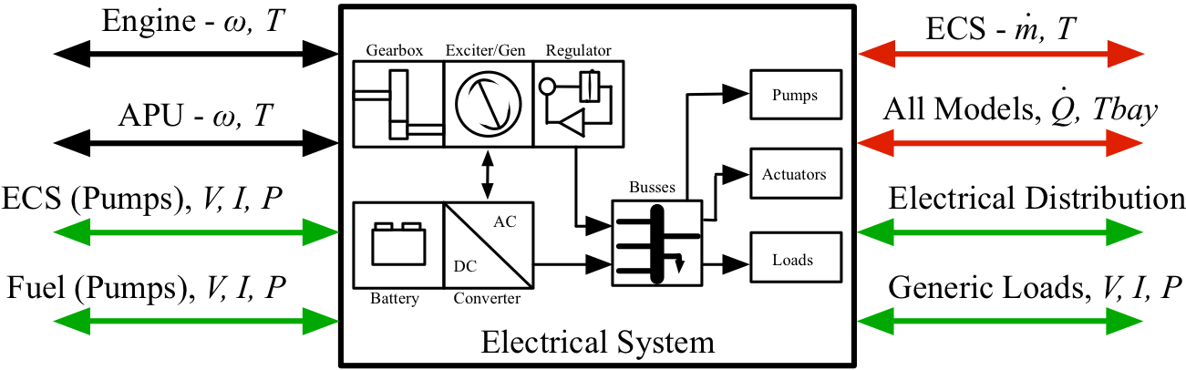

Figure 4.3. Electrical Power System Diagram

## Hydraulic Power System

The hydraulic power system manages the generation and consumption of hydraulic power. Hydraulic tanks, valves, engine-driven pumps, and electrical-driven pumps allow for the creation of custom hydraulic fluid systems. Hydraulic load modules operate on mass flow rate maps that determine the average power consumption for given stages of flight. Due to inefficiencies, thermal loads are generated in the hydraulic bays. Power for the pumps is taken from the engine gear box or electrical motors.

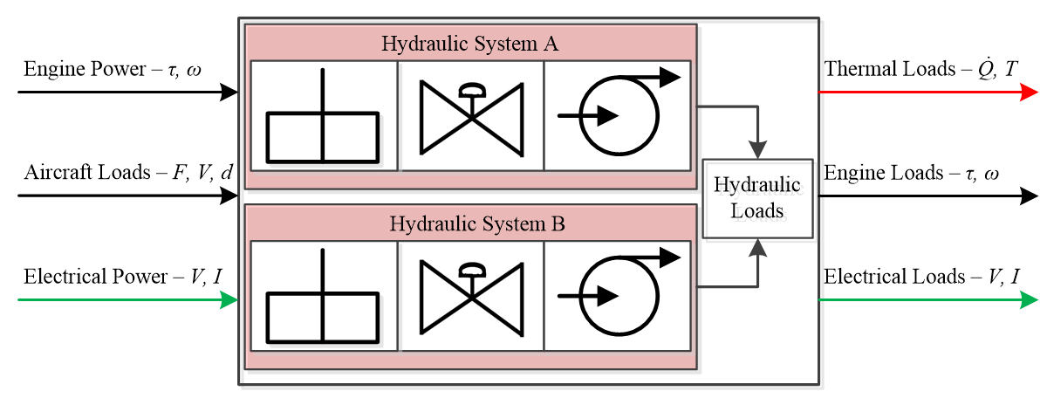

Figure 4.4. Hydraulic Power System Diagram

# Subsystem Modeling

The primary power-flow systems in an aircraft system can be broadly classified as:

1. Thermal management system
2. Fuel and oil thermal management system
3. Hydraulic system
4. Electrical system

In a typical aircraft architecture, the energy generation/consumption for non-propulsion operations occurs mainly through the above mentioned systems. These systems model the air-condition and cabin pressurization, the fuel-oil consumptions, the hydraulic and the electrical loads for operating various power consuming devices. A brief overview of each system, the mathematical modeling and simulink implementation of each component is presented below.

## Thermal Management System

The thermal management system consist of the Environmental control system (ECS) and the fuel/oil cooling system (FOCS). Apart from the thrust required to propel the aircraft, the ECS is the most energy consuming system. The primary function of the ECS is to condition, de-humidify, and appropriately pressurize the engine bleed air into the passenger cabin and the cargo hold. The air from the ECS is also used for cooling auxiliary systems such as electrical systems. The ECS usually consists of heat exchangers, control valves, turbocharger, fans, evaporator, water-separator and mixing junctions, where bleed air at high temperature (~400-500oC) and pressure (~300-400 kPa) goes through an *air-cycle* such that the desired pressure conditions are achieved inside the cabin. Usually, ram air is used as the cold fluid in the heat exchangers. The FOCS is primarily concerned with the fuel metering and heat transfer between the fuel and coolant. The FOCS consists of fuel tank, heat exchangers (air-cooled/oil-cooled), pumps, junctions, pipe/tubings *etc*. In Simulink, 1-D transient/steady state models for these components are developed.

### Cabin

The passenger cabin model is a 1-D (lumped parameter) model, whereby the properties of the air inside the cabin are considered as uniform throughout the cabin (no spatial dependence). The pressure and the temperature inside the cabin are derived through the conservation of mass and energy inside the control volume (cabin). The passengers inside the cabin are considered as the source of sensible heat. The heat transfer due to radiation and due to kinetic heating is accounted through approximate heat transfer coefficients. In Figure 5.1, a typical schematic of the control volume is presented. In most aircraft systems, conditioned air (subscript *SA*) is supplied to the cabin at desired pressure and temperature. A fraction of the supplied air, known as the recirculated air (*RA*) is driven out of the cabin by fans and is mixed with the upstream supplied air. The cabin pressurization is maintained by ejecting the rest of the cabin air (*EA*) to the environment. In Figure 5.2, the Simulink model of the cabin is presented to illustrate the different input/output parameters. The energy and mass balance inside the cabin is given by Eq. 5.1.1 and Eq. 5.1.2.

|  |
| --- |
| $${(m,T, P))}_{cabin}$$ $${\dot{Q}}_{gen}=n×{\dot{q}}_{pass}$$ $${\dot{(m},T, P) }_{SA}$$ $${\dot{(m},T, P) }_{RA}$$ $${\dot{(m},T, P) }_{EA}$$ |
| Figure 5.1. Schematic of passenger cabin control volume |

|  |
| --- |
| Conditioned air from PACK  (mdot\_kgps, temp\_K, pres\_kPa)  Ambient air condition  (temp\_K)  Mach number  Additional heat loads  (W)  Air properties in the cabin  (temp\_K, pres\_kPa)  Recirculated air properties in the cabin  (mdot\_kgps, temp\_K, pres\_kPa)  Supply air demand by the cabin  (mdot\_kgps) |
| Figure 5.2. Typical simulink high level scheme of the passenger cabin |

#### Mathematical Model

The energy balance inside the cabin is given by:

|  |  |  |
| --- | --- | --- |
|  |  | 5.1.1 |

where,



The mass balance inside the cabin is similarly given by:

|  |  |  |
| --- | --- | --- |
|  |  | 5.1.2 |

where,



The mass of air inside the cabin is related to the cabin pressurization through the equation of state (assuming ideal gas):

|  |  |  |
| --- | --- | --- |
|  |  | 5.1.3 |

Equations 5.1.1and Eq. 5.1.2 can be simplified to the following 1-D transient differential equations:

|  |  |  |
| --- | --- | --- |
|  |  | 5.1.4 |
|  |  | 5.1.5 |

In general, about 50% of the cabin air is recirculated. The heat load due to other subsystems is accounted by an increase in the recirculated air temperature.

#### Component Inputs and Outputs

Table 5.1. PASSENGER CABIN INPUTS/ OUTPUTS

|  |  |  |
| --- | --- | --- |
| **INPUT-1**: (symbol)  Supply air inflow bus: (mdot\_kgps)  Supply air inflow bus: (temp\_K)  Supply air inflow bus: (pres\_kPa) | **UNITS** | **DESCRIPTION** |
| Kg/s  K  kPa | Conditioned air flow rate upstream of the Cabin  Conditioned air temperature  Conditioned air pressure upstream of the Cabin |
|  | | |
| **INPUT-2**: (symbol)  Ambient temperature: () | **UNITS** | **DESCRIPTION** |
| K | Air temperature outside the aircraft |
|  | | |
| **INPUT-3**: (symbol)  Mach\_no | **UNITS** | **DESCRIPTION** |
|  | Mach number |
|  | | |
| **INPUT-4**: (symbol)  Equipment thermal load () | **UNITS** | **DESCRIPTION** |
| W | Heat load from other subsystems |
|  | | |
| **OUTPUT-1**: (symbol)  Supply air demand by cabin: (mdot\_kgps) | **UNITS** | **DESCRIPTION** |
| Kg/s | Supplied air required by the cabin to maintain desired temperature |
|  | | |
| **OUTPUT-2**: (symbol)  Cabin conditions: (temp\_K)  Cabin conditions: (pres\_kPa) | **UNITS** | **DESCRIPTION** |
| K  kPa | Air temperature inside the cabin  Air pressure inside the cabin |
|  | | |
| **OUTPUT-3**: (symbol)  From cabin to fan: (mdot\_kgps)  From cabin to fan: (temp\_K)  From cabin to fan: (pres\_kPa) | **UNITS** | **DESCRIPTION** |
| Kg/s  K  kPa | Recirculated air flow rate from the cabin  Recirculated air temperature from the cabin  Recirculated air pressure from the cabin |

The cabin parameters such as the area, shell thickness, sensible heat per passenger, etc., are defined through mask inputs, as shown in Figure 5.3

|  |
| --- |
|  |
| Figure 5.3. Mask Input parameters to Passenger Cabin |

#### Simulink Model

The Simulink model for the passenger cabin is given in Figure 5.4

|  |
| --- |
|  |
| Figure 5.4. Simulink block model of the cabin |

### Heat Exchanger

In most aircraft applications, air-air heat exchangers are employed in the Air-cycle machine (ACM). For the present implementation, a dynamic 1-D lumped parameter model is employed for characterizing the heat exchanger for B737 applications. The dynamic model is based on Ref. [4]

#### Mathematical Model

There are several types of compact heat exchanger, but the offset strip-fin has been the most widely used fin geometry for industries that require lightweight high-performance exchangers, due to its high heat transfer relative to heat exchanger volume, an important characteristic when considering the often reduced space available for its positioning.

|  |
| --- |
|  |

Figure . One layer of an offset strip-fin

|  |
| --- |
|  |

Figure . Geometric parameters of the offset strip-fin

***s***: Transverse spacing (free flow width).

***h***: Free flow height.

***t***: Fin thickness.

***l:*** Fin length.

Based on the above figure, the hydraulic diameter may be defined as:

|  |  |  |
| --- | --- | --- |
|  |  | 5.1.6 |

The correlation for the friction factor is in the form of a power-law of the type is given by

|  |  |  |
| --- | --- | --- |
|  |  | 5.1.7 |

***K1, a1, a2, a3, a4***: Power-law coefficients.

***Re***: Reynolds number.

;  

The mass flow rate in terms of the friction factor is given by:

|  |  |  |
| --- | --- | --- |
|  |  | 5.1.8 |

The convective heat transfer is calculated is:

|  |  |  |
| --- | --- | --- |
|  |  | 5.1.9 |

Where, *j* is the Coulburn factor, *Kf*is the fluid thermal conductivity, cp is the fluid specific heat at constant pressure, and is the fluid viscosity.

|  |
| --- |
|  |

Figure .. Fin thermal resistance

Heat transfer will occur in the fin through five different types of resistances, as presented in Figure 5.7. This resistances model both convection (using the heat transfer coefficient calculated previously) and conduction. After defining the equations for each resistance, a thermal circuit is built, and an equivalent thermal resistance *Req* is calculated. The details of deriving the equivalent thermal resistance can be found in Ref. [4]. Until this point, the basis of the model have been developed, the mass flow can be calculated based on the heat exchanger geometry, as are the thermal resistances. The last part is the model itself involves the heat exchange between the cold and hot fluids to/from the core mass, and the dynamics of the temperature in this core. Figure 5 presents the representation of this model with three main parts: hot fluid control volume, core mass and cold fluid control volume.

|  |
| --- |
|  |

Figure .. Core heat exchange model

 Hot mass flow

Cold mass flow

 Hot inlet temperature

 Hot outlet temperature

 Cold inlet temperature

Cold outlet temperature

Heat transferred from the hot fluid to the core mass

Heat transferred from the core mass to the cold fluid

 Energy accumulated in the core mass

Representation of the heat lost by the hot fluid due to the contact with the surface of the core mass is given by Eq. 5.1.10. It should be noted here that all developments are based on mean temperature, as defined in Eq. 5.1.11.

|  |  |  |
| --- | --- | --- |
|  |  | 5.1.10 |

|  |  |  |
| --- | --- | --- |
|  |  | 5.1.11 |

The use of mean temperatures is of great importance in this model, since it allows the heat transfer, and therefore the core mass temperature, to be obtained only as a function of the inlet temperatures of the fluids. It is required an expression for the mean hot temperature, which is not dependent on the fluid outlet temperature, which is to be determined. Isolating the hot outlet temperature in Eq.5.1.11 and replacing into Eq. 5.1.10 yields after some rearrangement:

|  |  |  |
| --- | --- | --- |
|  |  | 5.1.12 |

Using the same procedure for the cold line yields:

|  |  |  |
| --- | --- | --- |
|  |  | 5.1.13 |

Equations 5.1.12 and 5.1.13 present the mean cold and hot fluid temperatures as a function of the mean core mass temperature and known parameters, such as mass flow and equivalent thermal resistances (*Rh*and Rc). The transient response of the core energy is derived as:

|  |  |  |
| --- | --- | --- |
|  |  | 5.1.14 |

#### Component Inputs and Outputs

Table 5.2. HEAT EXCHANGER INPUTS/ OUTPUTS

|  |  |  |
| --- | --- | --- |
| **INPUT-1**: (symbol)  Ram air inflow bus: (mdot\_kgps)  Ram air inflow bus: (temp\_K)  Ram air inflow bus: (pres\_kPa) | **UNITS** | **DESCRIPTION** |
| Kg/s  K  kPa | Ram air required to run the ACM  Ram air temperature  Ram air pressure |
|  | | |
| **INPUT-2**: (symbol)  Bleed air inflow bus: (mdot\_kgps)  Bleed air inflow bus: (temp\_K)  Bleed air inflow bus: (pres\_kPa) | **UNITS** | **DESCRIPTION** |
| Kg/s  K  kPa | Bleed air from engine  Bleed air temperature upstream of hx  Bleed air pressure upstream of hx |
|  | | |
| **OUTPUT-1**: (symbol)  Ram air outflow bus: (mdot\_kgps)  Ram air outflow bus: (temp\_K)  Ram air outflow bus: (pres\_kPa) | **UNITS** | **DESCRIPTION** |
| Kg/s  K  kPa | Ram air at hx exit  Ram air temperature at hx exit  Ram air pressure at hx exit |
|  | | |
| **OUTPUT-2**: (symbol)  Bleed air outflow bus: (mdot\_kgps)  Bleed air outflow bus: (temp\_K)  Bleed air outflow bus: (pres\_kPa) | **UNITS** | **DESCRIPTION** |
| Kg/s  K  kPa | Bleed air at hx exit  Bleed air temperature downstream of hx  Bleed air pressure downstream of hx |
|  | | |
| **OUTPUT-3**: (symbol)  Misc. Data | **UNITS** | **DESCRIPTION** |
|  | Miscellaneous parameters such as Re, j, etc. |

The heat exchanger parameters are defined through mask inputs, as shown in Fig.

|  |
| --- |
|  |

Figure .. Mask Input parameters to the Heat exchanger

### Mixing Junction

The mixing junction provides the mixing of two air streams at the same pressure. The Simulink model for the mixing junction is based on the conservation of mass and enthalpy of the two incoming fluid stream. The pressure drop across the mixing junction is obtained by determining the discharge coefficient across the mixing junction. It is assumed that the incoming fluid ducts have the same area of cross-section, and the outlet duct has twice the area of cross-section as the inlet ducts. The coefficient of discharge (Cd) is determined from ASHRAE Handbook: Fundamentals (2009). In Figure 5.10, a typical schematic of the mixing junction is shown. The conservation of mass and enthalpy is given by Eq. 5.1.15 and Eq. 5.1.16

|  |
| --- |
| Input 2 Flow bus  (m\_dot, temp\_K, pres\_kPa)  Input 1 Flow bus  (m\_dot, temp\_K, pres\_kPa)  Output Flow bus  (m\_dot, temp\_K, pres\_kPa) |
| Figure 5.10. Typical high level scheme of mixing junction |

#### Mathematical model

Conservation of mass:

|  |  |  |
| --- | --- | --- |
|  |  | 5.1.15 |

Conservation of energy:

|  |  |  |
| --- | --- | --- |
|  |  | 5.1.16 |

Pressure loss:

|  |  |  |
| --- | --- | --- |
|  |  | 5.1.17 |

#### Components inputs and outputs

Table 5.3. MIXING JUNCTION INPUTS/ OUTPUTS

|  |  |  |
| --- | --- | --- |
| **INPUT-1**: (symbol)  Input 1 flow bus: (m\_dot)  Input 1 flow bus: (temp\_K)  Input 1 flow bus: (pres\_kPa) | **UNITS** | **DESCRIPTION** |
| Kg/s  K  kPa | Air flow rate from the upstream  Air temperature  Air pressure upstream of the mixing junction |
|  | | |
| **INPUT-2**: (symbol)  Input 2 flow bus: (m\_dot)  Input 2 flow bus: (temp\_K)  Input 2 flow bus: (pres\_kPa) | **UNITS** | **DESCRIPTION** |
| Kg/s  K  kPa | Air flow rate from the upstream  Air temperature  Air pressure upstream of the mixing junction |
|  | | |
| **OUTPUT-1**: (symbol)  Output flow bus: (m\_dot)  Output flow bus: (temp\_K)  Output flow bus: (pres\_kPa) | **UNITS** | **DESCRIPTION** |
| Kg/s  K  kPa | Air flow rate from the mixing junction  Air temperature  Air pressure from the mixing junction |

The mixing junction parameters such as the diameter of the ducts are defined through a mask parameter as shown in Figure 5.11.

|  |
| --- |
|  |
| Figure 5.11. Mask Input parameters to the mixing junction |

#### Simulink model

The Simulink model for the mixing junction is shown in Figure 5.12

|  |
| --- |
|  |
| Figure 5.12. Simulink block model of the mixing junction |

### Turbocharger

The turbocharger consists of a turbine driven by the exhaust gas and connected via a common shaft to the compressor, which compresses the air in the intake. The rotational speed (*N*) of the turbocharger shaft can be derived as a power (*P*) balance between the turbine and the compressor side. A typical Simulink modeling of the turbocharger, the turbine, and the compressor is shown in Figure 5.13-Figure 5.15.

|  |
| --- |
|  |
| Figure 5.13. Typical simulink model of a turbocharger |
| Turbine  Engine bleed  (m\_dot, temp\_K, pres\_kPa)  Compressor power  (W\_compressor)  Engine bleed  (m\_dot, temp\_K, pres\_kPa)  Shaft speed, N  Turbine power (W\_turbine) |
| **Figure 5.14. Turbine high level scheme** |
| Compressor  Engine bleed  (m\_dot, temp\_K, pres\_kPa)  Shaft speed, N  Engine bleed  (m\_dot, temp\_K, pres\_kPa)  Compressor power (W\_compressor) |
| Figure 5.15. Compressor high level scheme |

#### Mathematical model

The governing equations for the turbocharger is derived from Ref. [5]. The rotational speed (*N*) of the turbocharger shaft is related to the power balance between the turbine (*Pt*) and the compressor (*Pc*) side through the following first order differential equation:

|  |  |  |
| --- | --- | --- |
|  |  | 5.1.18 |

where the turbocharger speed is measured in rpm and *Jt* is the inertia of the turbocharger. Subsequently, the expressions for the compressor and turbine power are derived separately.

Assuming that the process is isentropic, the following relation between the temperature and pressure at the inlet (*Ti*, *pi*) and at the outlet (*To*, *po*) of the turbine can be derived:

|  |  |  |
| --- | --- | --- |
|  |  | 5.1.19 |

However, due to enthalpy losses across the turbine (e.g. incidence and friction losses), the expansion process is not isentropic in reality. Therefore, the turbine isentropic efficiency () is introduced. In the present Simulink model, the turbine isentropic efficiency has been modeled as a user-defined constant input. The outlet pressure *po* is also a user-defined constant. The turbine power (*Pt*) developed can be derived using Eq. 5.1.18 and Eq.5.1.19 as:

|  |  |  |
| --- | --- | --- |
|  |  | 5.1.20 |

where is the mass flow-rate across the turbine and *cp* is the specific heat of the bleed air. In the Simulink model of the turbocharger, the upstream turbine conditions (*Ti*, *pi*) are essentially the outlet flow conditions from the secondary heat exchanger. The power required by the compressor is an input to the turbine model. Using Eq. 5.1.20, the power delivered by the turbine (*Pt*) is calculated. The rotational speed (*N*) of the turbine is then derived using Eq. 5.1.18. The rotational speed of the turbine is taken as an input to the compressor. Efficiency and pressure maps are used to determine the flow conditions downstream of the compressor. The compressor efficiency is two-dimensional map, and can be defined in the following functional form:

|  |  |  |
| --- | --- | --- |
|  |  | 5.1.21 |

It is important to note that the units for pressure, temperature and the rotational speed in Eq. 5.1.21 should be carefully selected in order to be consistent with the efficiency map. In a similar manner, the pressure ratio (ratio of outlet pressure to the inlet pressure) is expressed through a two-dimensional map obeying the functional form:

|  |  |  |
| --- | --- | --- |
|  |  | 5.1.22 |

From the efficiency curve and the pressure ratio determined from the two-dimensional map, the power demand for the compressor can be determined from the following equation:

|  |  |  |
| --- | --- | --- |
|  |  | 5.1.23 |

At steady state the compressor power and the turbine power are equal.

#### Components inputs and outputs

**Table 5.4. TURBINE INPUTS/ OUTPUTS**

|  |  |  |
| --- | --- | --- |
| **INPUT-1**: (symbol)  Engine bleed: (m\_dot)  Engine bleed: (temp\_K)  Engine bleed: (pres\_kPa) | **UNITS** | **DESCRIPTION** |
| Kg/s  K  kPa | Bleed air flow rate from the upstream  Bleed air temperature  Bleed air pressure upstream of the turbine |
|  | | |
| **INPUT-2**: (symbol)  Compressor power: (W\_compressor) | **UNITS** | **DESCRIPTION** |
| W | Power demanded by the compressor |
|  | | |
| **OUTPUT-1**: (symbol)  Engine bleed: (m\_dot)  Engine bleed: (temp\_K)  Engine bleed: (pres\_kPa) | **UNITS** | **DESCRIPTION** |
| Kg/s  K  kPa | Bleed air flow rate at the turbine outlet  Bleed air temperature at the turbine outlet  Bleed air pressure at the turbine outlet |
|  | | |
| **OUTPUT-2**: (symbol)  Shaft speed: (N) | **UNITS** | **DESCRIPTION** |
| R.P.M | Rotational speed of the turbine |
|  | | |
| **OUTPUT-3**: (symbol)  Turbine power: (W\_turbine) | **UNITS** | **DESCRIPTION** |
| W | Power generated by the turbine |

**Table 5.5.** **COMPRESSOR INPUTS/ OUTPUTS**

|  |  |  |
| --- | --- | --- |
| **INPUT-1:** (symbol)  Engine bleed: m\_dot  Engine bleed: temp\_K  Engine bleed: pres\_kPa | **UNITS** | **DESCRIPTION** |
| Kg/s  K  kPa | Bleed air flow rate from the upstream  Bleed air temperature  Bleed air pressure upstream of the compressor |
|  | | |
| **INPUT-2:** (symbol)  Shaft speed: (N) | **UNITS** | **DESCRIPTION** |
| W | Rotational speed of the turbine |
|  | | |
| **OUTPUT-1:**  (symbol)  Engine bleed: m\_dot  Engine bleed: temp\_K  Engine bleed: pres\_kPa | **UNITS** | **DESCRIPTION** |
| Kg/s  K  kPa | Bleed air flow rate at compressor outlet  Bleed air temperature at compressor outlet  Bleed air pressure at compressor outlet |
|  | | |
| **OUTPUT-2**: (symbol)  Compressor power: (W\_compressor) | **UNITS** | **DESCRIPTION** |
| W | Power demanded by the compressor |

The turbine parameters such as the efficiency, the turbine exit pressure and the moment of inertia is defined through a mask parameter as shown in Figure 5.16.

|  |
| --- |
|  |
| Figure 5.16. Mask Input parameters to the turbine |

#### Simulink model

The Simulink model for the turbine and the compressor is shown in Figure 5.17 and Figure 5.18

|  |
| --- |
|  |
| Figure 5.17. Simulink block model of the turbine |

|  |
| --- |
|  |
| Figure 5.18. Simulink block model of the compressor |

### Valve

The function of the bleed valve is to regulate the amount of bleed air from the engine such that a desired cabin temperature is maintained inside the cabin.

|  |
| --- |
| Bleed air from the engine  (temp\_K, pres\_kPa)  Bleed air from the engine  (mdot\_kgps, temp\_K, pres\_kPa)  Cabin pressure  (pres\_kPa)  Cabin temperature  (temp\_K) |

Figure .. Bleed valve high level scheme

#### Mathematical model

The input to the bleed valve is the cabin temperature and pressure. The discharge coefficient of the bleed valve is taken as a constant. Depending on the cabin temperature, the area opening of the bleed valve is controlled by a proportional controller. In this way a desired flow rate is maintained across the valve.

#### Components inputs and outputs

Table 5.6. VALVE INPUTS/ OUTPUTS

|  |  |  |
| --- | --- | --- |
| **INPUT-1**: (symbol)  Flow from bleed: (temp\_K)  Flow from bleed: (pres\_kPa) | **UNITS** | **DESCRIPTION** |
| K  kPa | Bleed air temperature  Bleed air pressure |
|  | | |
| **INPUT-2**: (symbol)  Cabin temperature: (temp\_K) | **UNITS** | **DESCRIPTION** |
| K | Temperature inside the cabin |
|  | | |
| **INPUT-3**: (symbol)  Cabin pressure: (press\_kPa) | **UNITS** | **DESCRIPTION** |
|  | Pressure inside the cabin |
|  | | |
| **OUTPUT-3**: (symbol)  Output flow bus: (mdot\_kgps)  Output flow bus: (temp\_K)  Output flow bus: (pres\_kPa) | **UNITS** | **DESCRIPTION** |
| Kg/s  K  kPa | Metered air flow rate from the valve  Metered air temperature from the valve  Metered air pressure from the valve |

The valve parameters are shown in Figure 5.20

|  |
| --- |
|  |
| Figure 5.20. Mask Input parameters to the bleed valve |

#### Simulink model

The Simulink model for the bleed valve is given in Figure 5.21

|  |
| --- |
|  |
| Figure 5.21. Simulink block model of the bleed valve |

### Fan

The function of a fan in the ECS is to deliver the recirculated air from the cabin to a mixing junction, where the recirculated air is mixed with the conditioned air from the ECS. The fan model in Simulink determines the recirculated air properties and the fan power required. In Fig. 1 the scheme for the fan is presented

|  |
| --- |
| Recirculated air from cabin  (mdot\_kgps, temp\_K, press\_kPa)  Recirculated air from fan  (mdot\_kgps, temp\_K, press\_kPa)  Other output parameters  (mdot\_kgps, temp\_K, press\_kPa) |
| Figure 5.22. Typical simulink high level scheme of the fan |

#### Mathematical model

The fan model is based on two performance curves. The input to the curves is the volume flow rate in cfm, from which the static pressure and the fan power is determined.

#### Components inputs and outputs

Table 5.7. FAN INPUTS/ OUTPUTS

|  |  |  |
| --- | --- | --- |
| **INPUT-1**: (symbol)  Input flow bus: (mdot\_kgps)  Input flow bus: (temp\_K)  Input flow bus: (pres\_kPa) | **UNITS** | **DESCRIPTION** |
| Kg/s  K  kPa | Recirculated air flow rate from cabin  Recirculated air temperature from cabin  Recirculated air pressure from cabin |
|  | | |
| **OUTPUT-1**: (symbol)  From cabin to fan: (mdot\_kgps)  From cabin to fan: (temp\_K)  From cabin to fan: (pres\_kPa) | **UNITS** | **DESCRIPTION** |
| Kg/s  K  kPa | Recirculated air flow rate from the cabin  Recirculated air temperature from the cabin  Recirculated air pressure from the cabin |
|  | | |
| **OUTPUT-2**: (symbol)  Other output bus: (fan\_speed\_rpm)  Other output bus: (power\_kW)  Other output bus: (fan\_efficiency) | **UNITS** | **DESCRIPTION** |
| r.p.m  kW | Fan speed in r.p.m.  Fan power required  Fan efficiency |

The fan speed in r.p.m. is a mask parameter (Figure 5.23)

|  |
| --- |
|  |
| Figure 5.23. Mask Input parameters to the fan |

#### Simulink model

The Simulink model for the fan is given in Figure 5.24

|  |
| --- |
|  |
| Figure 5.24. Simulink block model of the fan |

## Fuel and Oil Thermal Management System

The fuel and oil thermal management system uses tanks, pumps, junctions, and heat exchangers in order to move mass and heat throughout the system and aircraft. In order to accomplish this energy is supplied as an input to some components in the form of pneumatic power (bleed air) or electrical power. These interconnections are relayed back to their respective sources in order to account for energy use in the fuel and oil system.

The following subsections detail the modeling of individual components and their implementation in the Simulink working environment.

### Fuel Tank

The fuel tank model tracks the time-varying fuel temperature, ullage temperature, and fuel mass. Mathematical modeling of the fuel tank is based upon conservation of energy and mass. In version , time-dependent pressure states are not calculated. Heat transfer is captured between the fuel, ullage, tank walls, and internal heat loads.

#### Mathematical Model

The mathematical model for the tank is based upon conservation of energy and mass. The following equations are implemented in the Simulink model of the fuel tank. Fuel mass is determined using conservation of mass:

|  |  |  |
| --- | --- | --- |
|  | $$m_{f}=∫{\dot{m}}_{in}-{\dot{m}}_{out}$$ | 5.2.1 |

The rate of change of the fuel temperature is a function of the heat transfer between the fuel and each wet section of wall, the fuel being added to the tank, heat transfer between the fuel and the ullage, and heat loads:

|  |  |  |
| --- | --- | --- |
|  | $$m_{f}C_{p,f}{\dot{T}}_{f}=\sum_{i=1}^{n}{h_{w,i}A_{w,i}\left(T_{wall,i}-T_{f}\right)+{\dot{m}}_{in}C_{p,in}\left(T_{in}-T_{f}\right)+}h_{fg}A_{fg}\left(T_{g}-T_{f}\right)+{\dot{Q}}_{load}$$ | 5.2.2 |

The rate of change of the ullage temperature is a function of the heat transfer between each dry section of wall and the heat transfer between the fuel and the ullage:

|  |  |  |
| --- | --- | --- |
|  | $$ρ_{g}V_{g}C_{p,g}{\dot{T}}_{g}=\sum_{i=1}^{n}{h_{d,i}A_{d,i}\left(T_{wall,i}-T_{g}\right)}+h_{fg}A_{fg}(T_{f}-T_{g})$$ | 5.2.3 |

Where the subscripts denote the following:

|  |  |  |  |
| --- | --- | --- | --- |
| $f$ | – Fuel | $w$ | – Wet |
| $g$ | – Ullage | $$d$$ | – Dry |
| $fg$ | – Fuel /Ullage boundary |

#### Component Inputs and Outputs

The fuel tank Simulink model acts solely as a thermal and fluid sink/source. All inputs and outputs are thermal/fluid energy domain. The fuel tank will accept a fluid flow bus containing flow rate, temperature, and pressure of a liquid. If the mass flow rate is non-zero, this fluid will be added to the mass of the fuel tank and enthalpy balances account for temperature differences. Additionally, ambient conditions affect the pressure of the fuel tank and heat loads can be dissipated in the fuel.

A fluid flow bus is output from the tank containing fluid temperature, pressure, enthalpy, and flow rate signals. The flow rate out is equivalent to the pump rate out of the fuel tank, which is supplied as an input to the Simulink model. Other outputs include the fuel mass remaining in the tank and the ullage temperature.

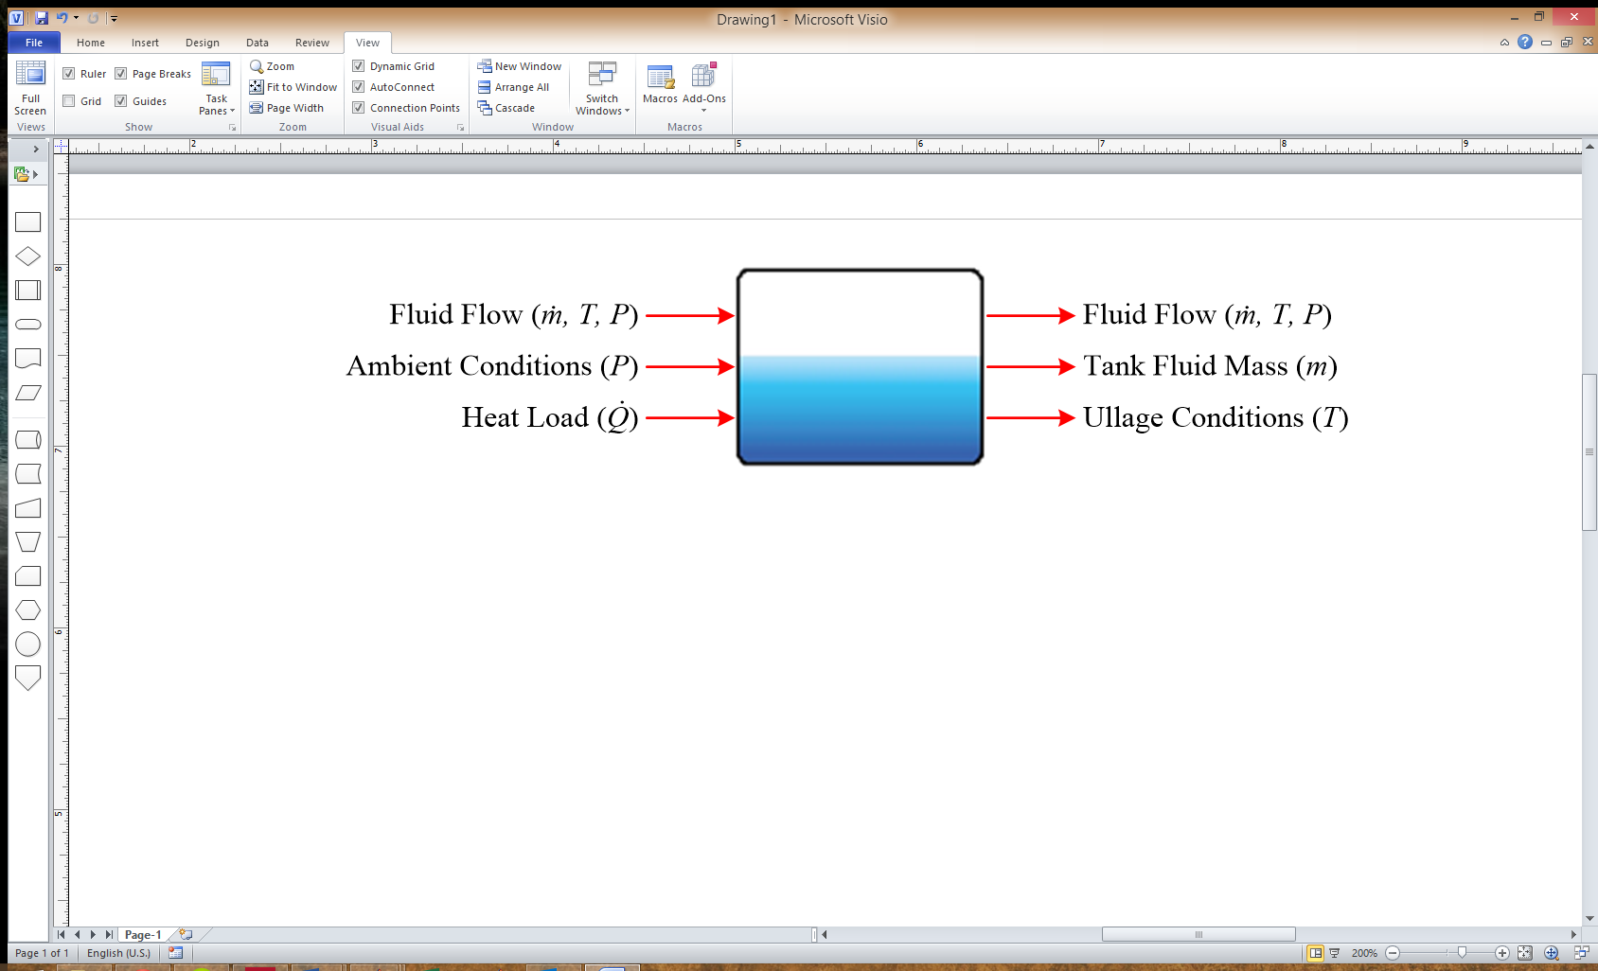

Figure 5.25. Fuel Tank Input and Output Energy Domains

The GUI of the fuel tank provides the ability to input multiple parameters specifying geometry, initial conditions, and thermal characteristics. These are detailed in Table 5.8.

Table 5.8. Fuel Tank Graphical User Interface Inputs

|  |  |  |  |
| --- | --- | --- | --- |
| **Tab Name** | **Input** | **Units** | **Description** |
| Geometry | Browse for area .m file | N/A | Browse for .m file containing wall area information for custom fuel tank |
| Fuel tank area .m file | N/A | Current fuel tank .m file being used |
| Area .m file directory | N/A | Directory location of current fuel tank .m file |
| Select tank | N/A | Left/Right wing or center fuel tank |
| Edit fuel tank area manually | N/A | Check box to open 2D lookup table block containing wall area data |
| Maximum Tank Volume | m3 | Tank volume (must be large enough to contain the initial condition of fluid mass) |
| Initial Conditions | Initial Fluid Mass | kg | Initial fluid mass in tank |
| Initial Fluid Temperature | °C | Initial fluid temperature in tank |
| Initial Ullage Temperature | °C | Initial ullage temperature in empty space of tank |
| Tank Pressurization | kPa | Over pressurization added to ambient conditions. Currently does not affect fluid properties. |
| Thermal Characteristics | Fuel to Ullage HTC | W/m­2K | Heat transfer coefficient between the fluid and ullage |
| Enable Wall Heat Transfer | N/A | Check box to enable wall heat transfer calculation. Increases computational complexity. |
| Wall to Fluid HTC | W/m­2K | Heat transfer coefficient between the wall and fluid. |
| Wall to Ullage HTC | W/m­2K | Heat transfer coefficient between the wall and ullage. |
| Internal Heat Load | W | Constant internal heat load. An external input provides the ability to apply a variable internal heat load. |

#### Simulink Model

The fuel tank Simulink component model is displayed in Figure 5.26. The GUI is shown in Figure 5.27 through Figure 5.29. The top level of the fuel tank Simulink model can be seen in Figure 5.30.

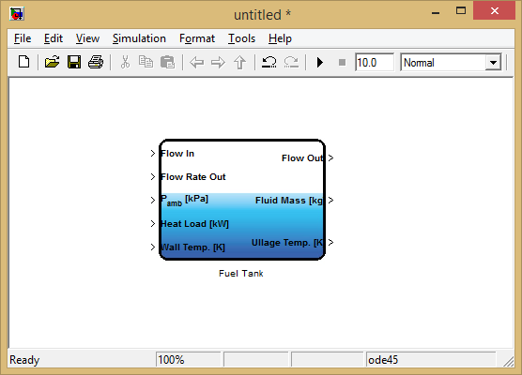

Figure 5.26. Fuel Tank Simulink Model

|  |  |
| --- | --- |
|  |  |
| Figure 5.27. Fuel Tank Geometry GUI | Figure 5.28. Fuel Tank Initial Conditions GUI |

|  |
| --- |
|  |
| Figure 5.29. Fuel Tank Thermal Characteristics GUI |

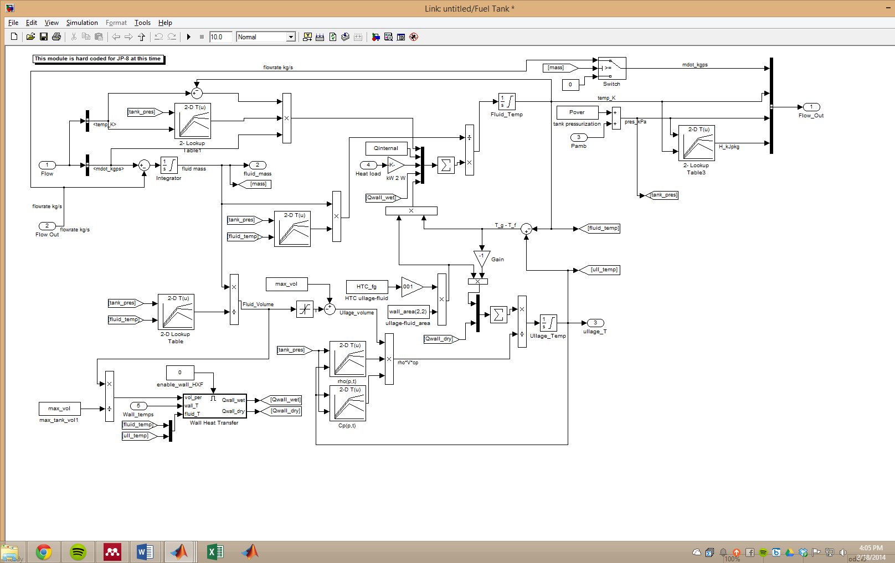

Figure 5.30. Fuel Tank Top-Level Simulink Diagram

### Fuel Pump

The fuel pump model determines a mass flow rate of fluid being pumped from a source through the use of pump performance maps. The pump model does not contain internal dynamic states and is based off of static relationships and look up tables.

#### Mathematical Model

The mathematical model for the fuel pump is based upon first principles equations.

The pump model determines a mass flow rate:

|  |  |  |
| --- | --- | --- |
|  | $$\dot{m}=\dot{v}ρ$$ | 5.2.4 |

Where the volumetric flow rate is determined using a pump performance curve and the pressure differential across the pump:

|  |  |  |
| --- | --- | --- |
|  | $$\dot{v}=f(ΔP)$$ | 5.2.5 |

Heat is added to the flow due to inefficiencies in the pump:

|  |  |  |
| --- | --- | --- |
|  | $$T_{out}=T_{in}+\frac{{\dot{Q}}_{heat}}{\dot{m}C_{p}}$$ | 5.2.6 |

Where the heat transfer rate is determined:

|  |  |  |
| --- | --- | --- |
|  | $${\dot{Q}}_{heat}=ΔP\dot{v}\left(\frac{1}{η}-1\right)$$ | 5.2.7 |

#### Component Inputs and Outputs

Since the fuel pump is a liquid pump, it has input fluid flow bus containing flow rate, temperature, and pressure. Pressure upstream from the pump also has to be supplied as an input. To maintain causality in the system, the components connected to the pump must calculate a pressure while the pump will calculate a mass flow rate. The final input to the pump is a shaft speed in RPM. If connected to an external motor model, the pump efficiency should be adjusted to account for the difference in motor and pump efficiency. Otherwise, both efficiencies can be lumped into the single term in the pump GUI.

Output signals include a fluid flow bus containing flow rate, temperature, and pressure, in addition to an output of electrical power. If a power factor is given in the pump GUI, the electrical power output will be a bus signal with real and reactive power.

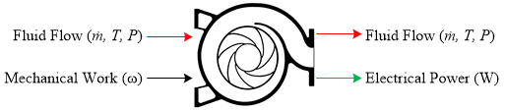

Figure 5.31. Fuel Pump Input and Output Energy Domains

The GUI of the fuel pump provides the ability to input multiple parameters specifying general operating conditions, efficiency, and power sources. These are detailed in Table 5.9.

Table 5.9. Fuel Pump Graphical User Interface Inputs

|  |  |  |  |
| --- | --- | --- | --- |
| **Tab Name** | **Input** | **Units** | **Description** |
| General | Map Type | N/A | Map type selection between head (m), pressure (kPa), or pressure (bar) vs. volumetric flow rate. |
| Select Map | N/A | Drop down menu containing available maps in the PumpProp.mat file loaded into the workspace. See section 5.2.2.3 for details. |
| Pump Overall Efficiency | N/A | Pump efficiency used in Eq. 5.2.7 |
| Add heat to flow? | N/A | Check box to add efficiency loss heat to flow. Leaving unchecked will add an output from the pump block containing the heat generated |
| Power | AC Powered? | N/A | Check box to enable AC power mode. |
| Power Factor | N/A | When AC Powered box is checked, a power factor can be entered in order to determine real/reactive power. |
| Mechanically Driven? | N/A | Check box to enable mechanical power output. AC power is set to zero. |

#### Pump Map

A *PumpProp*.*mat* file contains the maps for all pumps used in a model. The initialization code will search for the *PumpProp.mat* file on the MATLAB path and load it into the workspace. The variable loaded into the workspace will be called *PumpProp*, and each pump in a model will search for the variable.

The structure of the variable follows the outline shown in Figure 5.32. The yellow *Pump Designation* value shows up under the *Select Map* input to the pump GUI. Each pump map must have two entries in *Parameters*. One entry must be an array of volumetric flow rates with units m3/hr. This entry must be called ‘*q’*. The second entry must correspond to the values in the array *‘q’* and can be either pressure or head, labeled ‘*pres*’ or ‘*head’*, respectively. The units for pressure can be kilopascals or bar. The units for head must be in meters.

Figure 5.32. PumpProp Structure Format for Pump Lookup Maps

#### Simulink Model

The fuel pump Simulink component model is displayed in Figure 5.32. The GUI is shown in Figure 5.34 through Figure 5.35.

|  |
| --- |
|  |
| Figure 5.33. Fuel Pump Simulink Model |

|  |  |
| --- | --- |
|  |  |
| Figure 5.34. Fuel Pump General GUI | Figure 5.35. Fuel Pump Power GUI |

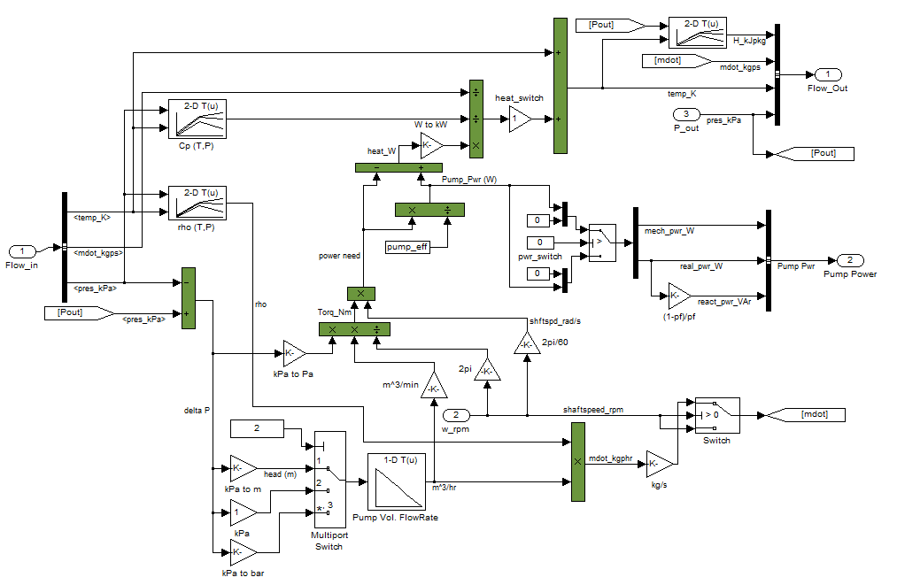

Figure 5.36. Fuel Pump Top-Level Simulink Diagram

### Oil Tank

See section 5.2.1.

### Oil Pump

See section 5.2.2.

### Air Cooled Oil Cooler

The air cooled oil cooler (ACOC) is a static model that transfers heat from the oil loop into the bypass duct of the engine. Currently the model is set up to read in heat exchanger details from a MATLAB workspace variable.

#### Mathematical Model

The ACOC utilizes static relationships as published by the heat exchanger manufacturer. These relationships are programmed into a heat exchanger lookup table that is described in Section 5.2.5.3.

The outlet temperature from the ACOC is calculated,

|  |  |  |
| --- | --- | --- |
|  | $$T_{out}=T_{in}+\frac{\dot{Q}}{\dot{v}C_{p}ρ}$$ | 5.2.8 |

Where, $\dot{Q}$ and $\dot{v}$ are taken from the heat exchanger lookup table.

The pressure drop across the heat exchanger is also taken from the heat exchanger lookup table:

|  |  |  |
| --- | --- | --- |
|  | $$P_{out}=P_{in}-ΔP$$ | 5.2.9 |

#### Component Inputs and Outputs

The ACOC handles an input fluid flow bus with mass flow rate, temperature, and pressure of the oil being routed through. The output is also a fluid flow bus with the same signals as are required in the input fluid flow bus.

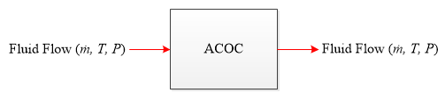

Figure 5.37. Air Cooled Oil Cooler Input and Output Energy Domains

Table 5.10. Air Cooled Oil Cooler Graphical User Interface Inputs

|  |  |  |  |
| --- | --- | --- | --- |
| **Tab Name** | **Input** | **Units** | **Description** |
| General | Select Heat Exchanger File | N/A | Browse for a .mat file containing the heat exchanger lookup values. |
| Heat Exchanger File | N/A | Displays the current heat exchanger file that is loaded. |
| Heat Exchanger File Location | N/A | The file location of the current heat exchanger file. |
| Refresh Heat Exchanger List |  | Check box to refresh the list of heat exchangers in the drop down menu. |
| Heat Exchanger | N/A | Drop down menu containing all ACOC heat exchangers in the heat exchanger file. |
| Bypass Conditions | Bypass Temperature | °C | Below this temperature the oil fluid flow bypasses the air cooled oil cooler. The temperature is measured every 10 second |
| Heat Exchanger Details | Pressure Loss | kPa | Displays the pressure loss for the selected heat exchanger. |
| Operating Pressure | kPa | Displays the operational pressure for the selected heat exchanger. |
| Heat Loss Rate | kW | Displays the heat transfer rate for the selected heat exchanger. |
| Rated Volumetric Flow Rate | m3/s | Displays the volumetric flow rate of fluid for the selected heat exchanger. |
| Heat Exchanger Mass | kg | Displays the mass for the selected heat exchanger. |

#### Heat Exchanger Lookup Table

The heat exchanger lookup table contains operational data that is loaded into the Simulink model prior to simulation. This data is used to calculate exit temperature and pressure of the fluid moving through the heat exchangers.

A *HeatExchangers*.*mat* file contains the lookup data. The initialization code will search for the *HeatExchangers.mat* file on the MATLAB path and load it into the workspace. The variable loaded into the workspace will be called *HX*, which is fixed due to the initialization code in the ACOC.

The structure of the variable follows the outline shown in Figure 5.38. The orange level corresponds to the type of heat exchanger. For the air cooled oil cooler, this is specified as *ACOC* and must remain as such so that the initialization code can load the correct data. The yellow and green levels correspond to manufacturer and model number of the heat exchangers. These can be customized as they are only used in populating the drop down list in the GUI for the ACOC. The blue *Parameters* must contain the five variables: *delP, Qdot, Vdot, mass, pres*. These correspond to the rated pressure loss through the heat exchanger, heat transfer rate, volumetric flow rate, mass, and operational pressure, respectively.

Figure 5.38. HX Structure Format for Heat Exchanger Lookup Values

#### Simulink Model

The air cooled oil cooler Simulink GUI is shown in Figure 5.39 through Figure 5.41.

|  |  |
| --- | --- |
|  |  |
| Figure 5.39. Air Cooled Oil Cooler General GUI | Figure 5.40. Air Cooled Oil Cooler Bypass Conditions GUI |

|  |
| --- |
|  |
| Figure 5.41. Air Cool Oil Cooler Heat Exchanger Details GUI |

### Stochastic Heat Loads

The heat loads model applies a stochastic increase to the temperature of a flow. The temperature increase uses normally distributed white noise as an input to the temperature. The model allows the user to define a fixed or random seed in order to capture repeatable heat loads or truly model stochastic behavior.

#### Mathematical Model

The temperature of the flow out is found by integrating the white noise signal and adding it to the input flow temperature,

|  |  |  |
| --- | --- | --- |
|  |  | 5.2.10 |

Integration has a lower saturation of zero to prevent the heat load from removing heat from the flow.

#### Component Inputs and Outputs

The input and output of the heat load block is a fluid flow bus containing pressure, temperature, and mass flow rate variables.

The GUI contains three inputs for the user to specify the intensity of the heat loads.

Table 5.11. Heat Load Graphical User Interface Inputs

|  |  |  |
| --- | --- | --- |
| **Input** | **Units** | **Description** |
| Noise Power | ~ | Specifies the height of the PSD of the white noise. |
| Sample Time | s | Specifies the correlation time of the noise. |
| Seed | ~ | Specifies the starting seed of the random number generator. If this value is fixed, the heat load is repeated given the same noise power and sample time. |

|  |
| --- |
|  |
| Figure 5.42. Stochastic Heat Loads GUI |

## Electrical Power System

In this section, the main building blocks of aircraft electrical power systems including generators, exciters, battery units, power converters will be explained and modeling details will be presented.

### Generator

More-electric aircrafts are moving towards ac generation systems with variable frequency operation. This section will provide mathematical models, dynamic inputs/outputs and *simulink* model of a wound-field synchronous generator. A generic structural diagram of the generator is shown in Fig. 5.43.

|  |
| --- |
| Macintosh HD:Users:veyselbuyukdegirmenci:Desktop:Synchronous Generator.tiff  Fig. 5.43. Synchronous Generator High Level Scheme |

#### Mathematical Model

This is a standalone generator model. Common generator models assume either an infinite bus or a voltage supply connected to the machine terminals (Krause et. al, 2002). However, such an implementation would require the knowledge of line voltages and would violate the causality of the system. Therefore, a voltage-based model is created. This way, the load information would not be necessary while producing line voltage. An accurate implementation of this approach would require line transients such as time rate of change in the line inductance currents and voltage drop across the line reactors to be monitored. However, a singular perturbation approach presented in (Sauer and Pai, 1998) is followed to mitigate this problem and optimize the system model details and simulation speed. To achieve faster simulations, the models are implemented in a synchronous reference frame. Synchronous machine dynamic model is as follows:

|  |  |
| --- | --- |
| , | (5.3.1) |
| , | (5.3.2) |
| , | (5.3.3) |
| , | (5.3.4) |

where  and  are the direct and quadrature axis per-unit reactances, respectively;  and  are the direct and quadrature axis per-unit transient reactances, respectively;  and  are the direct and quadrature axis per-unit subtransient reactances, respectively;  and  are the direct and quadrature axis field winding per-unit transient time constants, respectively;  and  are the direct and quadrature axis field winding per-unit subtransient time constants, respectively. These quantities are defines as:

|  |  |
| --- | --- |
| , | (5.3.5) |
| , | (5.3.6) |
| , | (5.3.7) |
| , | (5.3.8) |
| , | (5.3.9) |
| , | (5.3.10) |
| , | (5.3.11) |
| , | (5.3.12) |

and the synchronous machine terminal voltages are:

|  |  |
| --- | --- |
| , | (5.3.13) |
| , | (5.3.14) |

where  and  are the transmission line per-unit resistance and reactance, respectively;  is the per-unit electrical frequency (typical base value is 377 rad/s),  is the synchronous machine per-unit stator resistance. Synchronous machine per-unit electromagnetic torque is

|  |  |
| --- | --- |
| . | (5.3.15) |

To account for the heat load of the generators, the power losses are computed as

|  |  |
| --- | --- |
|  | (5.3.16) |

where is the base power, is the per-unit input torque to the generator from the gearbox.

#### Component Inputs and Outputs

The synchronous generator model has two electrical inputs, one mechanical input, one mechanical output, two electrical outputs and one thermal output. The electrical inputs are the line currents in the synchronous reference frame (*idq0*) and the field current (*ifd*) and their units are amperes. These quantities are converted into per-unit and the base currents *IBDQ* and *IBFD* should be defined in the MATLAB workspace. The mechanical input is the shaft speed from the gearbox model and its unit is rad/s. The two electrical outputs are the synchronous frame line voltages (*vdq0*) and field winding voltage (*vfd*). The mechanical output is the shaft torque (*T­em*) and its unit is N-m. The thermal output is the generator power loss (*Ploss*) and it is defined in Watts. The per-unit synchronous machine model requires the user to define the base quantities. Model interface is summarized below and the base values are listed in Table 5.12.

Inputs to the model are:

* **idq0** – Synchronous frame line current (Units – Ampere)
* ***ω***– Shaft speed (Units – rad/s)
* **ifd** – Field Current (Units – Ampere)

Outputs from the model are:

* **vdq0** – Synchronous machine line voltage (Units – Volt)
* **Te** – Electromagnetic shaft torque (Units – N-m)
* **vfd** – Field Winding Voltage (Units – Volt)
* **Ploss** – Power loss (Units – Watt)

Table 5.12: Base values for per-unit synchronous machine model

|  |  |
| --- | --- |
| *Base Quantity*: | Definition |
| *VBDQ*: | Direct and quadrature axis armature voltage base values (V) |
| *IBDQ*: | Direct and quadrature axis armature current base values (A) |
| *SB*: | Base power  (VA) |
| *TB*: | Base torque  (N-m) |
| *ωB*: | Base electrical frequency (rad/s) |
| *VBFD*: | Base field winding voltage (V) |
| *IBFD*: | Base field winding current (A) |

#### Simulink Model

The *simulink* block diagram of the implemented synchronous generator is shown in Fig. 5.44.

|  |
| --- |
| Fig. 5.44. Synchronous generator *simulink* block diagram. |

### Exciter System

The synchronous machine described in Section 5.3.1 requires a field current supply. Commonly, another wound-field or permanent magnet synchronous generator coupled to the main generator shaft is utilized to provide this current. The output terminals are rectified and directly connected to the main generator field terminals. This field current must be provided independent of the generator and should be controlled properly to regulate the generator terminal voltage. A battery provides the exciter-generator field current, and it is regulated through a dc/dc converter. A generic structural diagram is shown Fig. 5.45.

|  |
| --- |
| Macintosh HD:Users:buyukdegirmenci:Desktop:Exciter Model.tiff  Fig. 5.45. Exciter Generator High Level Scheme |

#### Mathematical Model

The mathematical model of the exciter generator is identical to the model provided in Section 5.3.1.1. A generic exciter controller mathematical model will be provided in this section. The field-controller converter duty cycle (*m*) is obtained from:

|  |  |
| --- | --- |
| , | (5.3.17) |
| , | (5.3.18) |

where

|  |  |
| --- | --- |
| . | (5.3.19) |

Here *k1*, *k2*, and *k3* are controller gains, *r* is an arbitrary variable and *m* is the dc/dc converter duty ratio. The reference line voltage is *Vref* and measured line voltage is *Vline*.

#### Component Inputs and Outputs

The synchronous generator model has four electrical inputs, one mechanical input, one mechanical output, two electrical outputs and one thermal output. The electrical inputs are the battery voltage (*vdc*), line voltage (*Vline*), line voltage reference (*Vref*), and main generator field terminal voltage (*vfd*) and their units are volts. These quantities are converted into per-units and the base voltages *VBDQ* and *VBFD* should be defined in the MATLAB workspace. The mechanical input is the shaft speed from the gearbox model and its unit is rad/s. The electrical outputs are the main generator field current (*ifd*) and the battery current (*idc*). The mechanical output is the shaft torque (*T­em*) and its unit is N-m. The thermal output is the generator power loss (*Ploss*) and it is defined in Watts. The per-unit synchronous machine mode requires the user to define the base quantities.

#### Simulink Model

The *simulink* block diagram of the implemented exciter is shown in Fig. 5.46.

|  |
| --- |
| Macintosh HD:Users:buyukdegirmenci:Desktop:Exciter.tiff  Fig. 5.46. Exciter system block diagram |

### Generator System

A generator system block implements a generic power generation unit consisting of a gearbox, a synchronous generator, a synchronous exciter and exciter controls. These individual systems are as described before and their mathematical models and details will not be repeated here. A generic structural diagram is shown in Fig. 5.47.

|  |
| --- |
| Macintosh HD:Users:buyukdegirmenci:Desktop:Generation Unit.tiff  Fig. 5.47. Generator system structural diagram |

#### Component Inputs and Outputs

The synchronous generator model has two electrical inputs, one mechanical input, one mechanical output, two electrical outputs and one thermal output. The electrical inputs are the line currents in the synchronous reference frame (*idq0*) and the exciter system supply voltage (*vdc*). The line currents are converted into per-unit and the base value is *IBDQ*. The mechanical input is the jet engine speed from the low-pressure spool and its unit is RPM. The two electrical outputs are the synchronous frame line voltages (*vdq0*) and exciter system supply current (*idc*). The mechanical output is the electromagnetic torque (*T­em*) and its unit is N-m. The thermal output is the generator power loss (*Ploss*) and it is defined in Watts. The user inputs and outputs are summarized below. Inputs to the model are:

* **engine speed** – Jet engine low pressure spool speed (Units – RPM)
* **battery voltage** – Exciter system supply voltage (Units – Volt)
* **idq0** – Synchronous reference frame line currents (Units – Ampere)

Outputs from the model are:

* **vdq0** – Synchronous reference frame line voltages (Units – Volt)
* **battery current** – Exciter system supply current (Units –Ampere)
* **engine torque** – Electromagnetic torque on the low pressure spool (Units – N-m)
* **Ploss** – Heat rejected to the cooling system or ambient (Units – Watt)

This system requires the following mask inputs, as shown in Fig. 5.48.

* **Machine Preset** – A preset main generator electrical and mechanical parameters, base quantities and other variables based on the selected power level. The variables are automatically loaded once a preset is selected.
* **Gear Box Parameters** – Gearbox parameters such as conversion ratio, efficiency, etc. need to be stored in the workspace. This entry requires the “.mat” file that stores gearbox parameters.
* **Fan Load** – If a cooling fan is installed on the shaft, this entry requires its speed vs. load torque characteristics.
* **Exciter Machine Parameters** – The exciter generator parameters need to be stored in the workspace. This is independent of the main generator parameters. This entry is the path to the file that the exciter generator parameters are stored.

|  |
| --- |
| Macintosh HD:Users:buyukdegirmenci:Dropbox:Updated Power Flow Rolls Royce:Generator_help:Generator_mask.png  Fig. 5.48. Mask inputs to the generator system block. |

#### Simulink Model

The *simulink* block diagram of the implemented generator unit is shown in Fig. 5.49.

|  |
| --- |
| Macintosh HD:Users:buyukdegirmenci:Dropbox:Updated Power Flow Rolls Royce:Generator_help:generator_block.png  Fig. 5.49. Generator system Simulink diagram. |

### Battery

The battery is the source of DC power in the aircraft electrical system. This section deals with the implementation of a lithium-ion battery, its mathematical model and the component inputs and outputs. In the following model, battery parameters are determined from laboratory tests on a sample lithium-ion battery (Panasonic CGR18650A). The model is generic and can be used to implement a wide range of batteries, including Li-ion, NiMH and lead-acid batteries. However, the battery circuit model parameters have to be estimated using a battery testing procedure (Kroeze and Krein, 2008).

#### Mathematical model

The mathematical model described in this section is used to implement a lithium-ion battery. The battery capacity is a function of the charging/discharging rates *i*(*t*), temperature *T*(*t*) and cycle number *ncycle* and a rate factor *f*(*i*(*t*)) which is a function of current. The rate factor is used to account for undesired side reactions with increase in current magnitude. The dynamic capacity of the battery represented by its state of charge (SOC), is a function of the abovementioned factors and given by the following expression.

 (5.3.20)

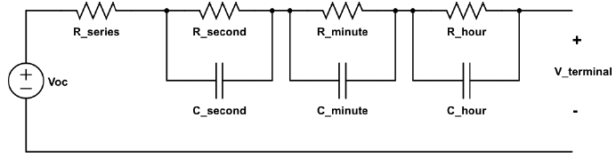

Fig. 5.50. Electrical equivalent circuit of the battery model.

The battery is modeled using the notion of multiple scale time constants, each at the level of seconds, minutes and hours. In the electrical equivalent circuit, each time constant can be modeled as a resistance-capacitance combination, as shown in Fig. 1. Measurements of the circuit parameters are found using a battery testing apparatus and recording the test sequences and data corresponding to open circuit voltage (*Voc*) and terminal voltage (*Vt*) versus SOC at room temperature. Each parameter (resistance and capacitance) in the model shown in Fig. 1, is a nonlinear function of SOC. For a practically useable model, each parameter is represented as a polynomial function of the SOC up to sixth order given as

 (5.3.21)

The coefficients *A*0-*A*6 are obtained by a best-fit polynomial expression on the experimentally determined data points. From the equivalent circuit, the battery terminal voltage can be calculated as follows.

 (5.3.22)

where *I* refers to the series current flowing in the circuit. The various resistance-capacitance combinations (*Rs*-*Cs*, *Rm*-*Cm*, *Rh*-*Ch*) refer to the time constants corresponding to the second, minute and hour time scales.

#### Component Inputs and Outputs

A high-level block diagram with inputs and outputs to the model are shown in Fig. 2. The internal blocks indicate the sequence of steps executed to compute the battery dc bus voltage output. Also, the total power loss in the battery pack is computed as the sum of power dissipated in various resistors of the electrical equivalent circuit. The net charge/discharge detection block determines whether the net effect is charging or discharging, depending on the difference between the magnitudes of charging and discharging currents. This information along with the current flowing in the circuit is used to compute the dynamic SOC, which enables the calculation of the terminal voltage using (5.3.19). A single cell lithium-ion battery can provide a nominal dc voltage of 3.81 V. By connecting a number of cells in series, a required dc bus voltage can be realized. Connection of parallel modules enables to increase the current capacity of the battery module.



Fig. 5.51. High-level block diagram of the battery model

The user inputs and outputs are given below. Inputs to the model are:

* **CTOUT** - Discharging current magnitude (Units – Ampere)
* **CTIN** - Charging current magnitude (Units – Ampere).

Outputs from the model are:

* **VDC** - Voltage output of the battery module consisting of series and parallel cells (Units – Volt)
* **PLOSS** - Power lost in the battery due to its internal resistances (Units – Watt)

The battery model requires the following mask input values, as shown in Fig. 3.

* **Number of cells in each module\*** - Determines the series voltage of the entire string
* **Number of modules**\* - Determines the number of parallel battery modules, each module consisting of its string
* **Initial State Of Charge** - Nominal initialization done between 0.9-1.0 (Range: 0-1).

\*These values can be changed even during the course of simulation

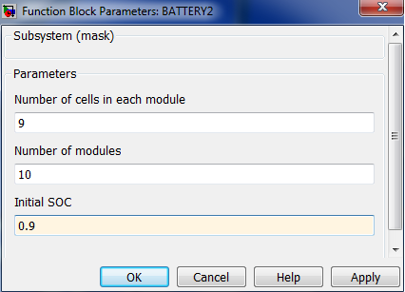

Fig. 5.52. Mask inputs to the battery model

#### Simulink Model

The implemented simulink model of the battery is shown in Fig. 4.

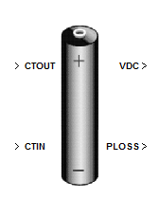

Fig. 5.53. Simulink implementation of the battery model

### Inverter

The three-phase inverter block converts the dc bus voltage supplied from the battery to ac voltage, which interfaces with the rest of the AC system through a step-up transformer unit. Since the inverter is modeled in the *dq*0 reference frame, the inverter output voltages will also become constant values in steady state due to the *abc*-*dq*0 transformation.

#### Mathematical Model

The battery voltage serves as the dc bus input voltage (*Vdc*) to the battery. The other input needed to control the three-phase inverter are switching (or modulating) functions. Since the inverter is an averaged model in *dq*0 frame, the switching functions (*q*) are also steady state averaged signals. When sinusoidal pulse width modulation method is used to control the inverter switches, the output L-L (rms) voltage of the inverter can be given as

 (5.3.23)

Because of the reference frame transformation, the switching functions for the three-phase inverter are also constant values, instead of sinusoidal functions, so that the output voltages are constant values. The phase of the inverter output voltages with respect to the rest of the AC system can be changed by modifying the constant vector passed as input into the switching function block.

#### Component Inputs and Outputs



Fig. 5.54. High-level block diagram of the inverter model

The user inputs and outputs are given below. Inputs to the model are:

* **DC bus voltage** – DC link voltage for the inverter obtained from the battery output voltage (Units – Volt)
* **Switching function** – A 1x3 vector signal with constant values passed as modulating functions to control the inverter output voltage
* **Inverter AC side current** – Inverter output current demand in *dq*0 frame (Units- Ampere)

Outputs from the model are:

* ***dq*0 output voltage** – Three-phase inverter output voltage in *dq*0 frame (Units – Volt)
* **DC link current** – Computed based on the inverter AC output current and passed as the dc bus current demand feedback to the battery (Units – Ampere)
* **Power loss** – Calculated as the conduction and switching losses in the inverter (Units – Watt)

The inverter model requires the following mask inputs, as shown in Fig. 2.

* **Rise time and fall time** – Depends on the specific type of semiconductor switch and can be obtained from the corresponding datasheets (Units – Second). This is useful to calculate switching losses.
* **On state *Vce* drop** - The voltage drop (ideally desired to be 0) across the switch during conduction is used to compute the conduction losses in the switch (Units – Volt)
* **Switch ing frequency** – User-defined PWM frequency that determines the number of times that each switch is turned on and off and is required to compute switching losses (Units - Hz)
* **Number of switches** – Refers to the number of semiconductor switches in the inverter. Usually, a two-level inverter configuration is used, which has six power switches.

**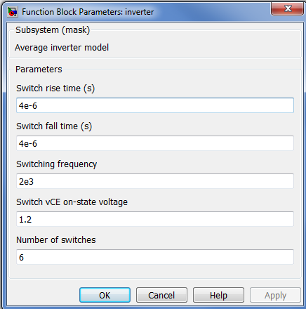**

Fig. 5.55. Mask inputs to the inverter model

### AC Loads

The AC electrical loads are classified into constant power, constant current and constant impedance loads, for different user requirements. These loads are also modeled in the *dq*0 reference frame. The loads are modeled as lumped quantities. Assuming a balanced three-phase system, the zero axis electrical quantities are generally zero valued in steady state and therefore ignored.

#### Mathematical Model

Although the loads are divided as power, current and impedance loads, the generators require the dq0 axis currents drawn by each load, as feedback signals. In general, the complex power *S* can be expressed as

 (5.3.24)

where *V* and *I*\* are the voltage and complex conjugate of the current drawn.

For the power loads, the active (*P*) and reactive components (*Q*) of the complex power can be expressed as

 (5.3.25)

From the above equation, after separating the real and imaginary parts , the active and reactive currents can be given as

,  (5.3.26)

For the impedance loads, the active and reactive currents can be given as

,  (5.3.27)

The *dq* currents drawn by the loads are computed using (5.3.23) and (5.3.24) and are passed as feedback signals to the corresponding generator bus.

#### Component Inputs and Outputs

AC loads can be inserted in one of the two modes: Internal or External. The internal mode can be used when the loads are fairly constant over the entire mission profile or drive cycle. The loads for this mode can set up through a dialog box obtained by double-clicking the load block. This is shown in Fig. 1 below. The external mode is used when the loads are varying over time and required to be set up as a vector of inputs in the following order of power, current and series impedance quantities:

1. Active Power [P] (Units –Watt)

2. Reactive Power [Q] (Units – Var)

3. Current [I] (Units – Ampere)

4. Resistance [R] (Units – Ohm)

5. Reactance [X] (Units – Ohm)

When the control type in dialog box in Fig. 1 is selected to ‘*ext*’ (external mode), the load parameters entered into the dialog box are ignored and the external load vector is enabled in the subsystem.

**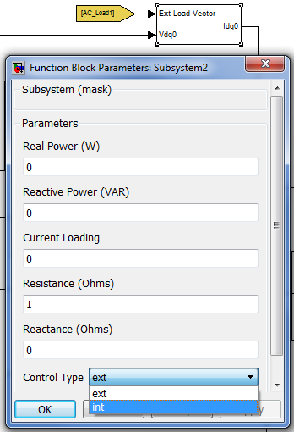**

Fig. 5.56. Mask inputs for the load model

It is important to note that heavy loading of the system before the generator voltage has built to a stable output can result in instabilities, eventually leading to system crashing down. So care has to be taken as to ensure a time delay for loading of the generator system.

### Transformer

The transformer block converts the primary winding voltage level or provides galvanic insulation. A complete dynamic model is omitted for faster simulations. A steady-state electrical model is implemented. Only resistive voltage drops are included and reactances are neglected. The model is flexible and can be used as a single-phase or multi-phase transformer interchangeably. The inputs and outputs are in the synchronous reference frame.

#### Mathematical Model

A simplified circuit diagram for the modeled transformer is shown in Fig. 5.57. Here the magnetic coupling is ideal and only copper losses are modeled. The input-output electrical relation is:

|  |  |
| --- | --- |
|  | (5.3.28) |

where *Vp* is the primary winding voltage, *V­s* is the secondary winding voltage, *ip* is the primary winding current, *is* is the secondary winding current, and *Np* and *Ns* are the primary and secondary windings number of turns, respectively.

|  |
| --- |
| Macintosh HD:Users:buyukdegirmenci:Desktop:Transformer.tiff  Fig. 5.57. Simplified circuit model of a transformer |

#### Component Inputs and Outputs

|  |
| --- |
| Macintosh HD:Users:buyukdegirmenci:Desktop:Transfor.tiff  Fig. 5.58. Transformer model structural diagram. |

The user inputs and outputs are given below. Inputs to the model are:

* **Vin** – Primary winding voltage input (Units – Volt)
* **Iout** – Secondary winding current output (Units – Ampere)

Outputs from the model are:

* **Vout** – Secondary winding output voltage (Units – Volt)
* **Iin** – Primary winding current (Units – Ampere)

The transformer model requires the following mask inputs, as shown in Fig. 5.59.

* **Primary Winding Resistance** – (Units – Ohm)
* **Secondary Winding Resistance** - (Units – Ohm)
* **Number of Turns in Primary**
* **Number of Turns in Secondary**

|  |
| --- |
| Macintosh HD:Users:buyukdegirmenci:Desktop:Screen Shot 2014-01-09 at 4.27.05 PM.png  Fig. 5.59. Mask inputs for the transformer model. |

### Rectifier

The rectifier block converts ac voltage to dc voltage, which interfaces with the rest of the DC system. This is an active rectifier and it is modeled in the synchronous *dq*0 reference frame. The active rectifier control algorithm is omitted and a simplified model is implemented.

#### Mathematical Model

A voltage-based model is implemented and a dc-link inductor is assumed. The rectifier is modeled as:

|  |  |
| --- | --- |
| , | (5.3.29) |
| , | (5.3.30) |
| , | (5.3.31) |
| , | (5.3.32) |

where, *Vout* is the output dc voltage, *iout* is the output dc current, and *m* is the modulation depth.

#### Component Inputs and Outputs

The user inputs and outputs are given below. Inputs to the model are:

* **vqd0** – Input line voltage in the synchronous reference frame (Units – Volt)
* **cont** – Converter modulation depth. It is a number between 0 and 1.
* **Vout** – Output dc voltage level (Units – Volt)

Outputs from the model are:

* **iout** – Output dc current level (Units – Ampere)
* **iqd0** – Input line current in the synchronous reference frame (Units – Ampere)

The rectifier model requires the following mask inputs, as shown in Fig. 5.60.

* **Inductance** – DC link filter inductor (Units – Henry)

|  |
| --- |
| Macintosh HD:Users:buyukdegirmenci:Desktop:Screen Shot 2014-01-09 at 5.10.20 PM.png  Fig. 5.60. Mask inputs for the active rectifier |

#### Simulink Model

The *simulink* block diagram of the implemented rectifier is shown in Fig. 5.61.

|  |
| --- |
| Macintosh HD:Users:buyukdegirmenci:Desktop:rec.tiff  Fig. 5.61. Simulink diagram of the implemented rectifier. |

## Hydraulic Power System

The hydraulic system uses reservoirs, engine driven pumps, relief valves, and hydraulic load modules to simulate the power generated and consumed by an aircraft. An engine driven pump module takes mechanical energy from the engine and uses it to pressurize the hydraulic system. Hydraulic loads dissipate energy from the system when moving flight control surfaces such as the ailerons, rudder, and elevator.

The following subsections detail the modeling of individual components and their implementation in the Simulink working environment.

### Engine Driven Pump

The engine driven pump provides a method to pressurizing the hydraulic system. Most hydraulic systems on commercial aircraft operate around 3000 psi and draw from a reservoir of fluid that is at, or just above, atmospheric conditions. In version of the PowerFlow toolset, the EDP operates with a fixed displacement and fixed rpm. Dynamics caused by the startup and shutdown of the engine are not captured at this time. Overall pump efficiency is currently fixed for each simulation.

#### Mathematical Model

The mathematical model for the engine driven pump is based upon first principle relationships between mass flow rate, pressure, density, and pump properties.

The mass flow rate through the pump is calculated,

|  |  |  |
| --- | --- | --- |
|  |  | 5.4.1 |

where  is the fluid density in kg/m3,  is the pump displacement in m3/rev,  is the pump shaft rotational frequency in rev/s, and  is the pressure differential across the pump in Pascals.

The leakage flow coefficient (Eq. 5.4.2) is determined based upon the assumption that it is linearly proportional to the Hagen-Poiseuille coefficient (Eq. 5.4.3).

|  |  |  |
| --- | --- | --- |
|  |  | 5.4.2 |
|  |  | 5.4.3 |

where  is the dynamic viscosity of the fluid in Pa∙s,  is the volumetric efficiency of the pump, and the subscript  represents nominal values.

The torque applied to the driving shaft of the pump where  is the mechanical efficiency of the pump,

|  |  |  |
| --- | --- | --- |
|  |  | 5.4.4 |

#### Component Inputs and Outputs

The first input to the hydraulic fluid pump is the fluid bus containing flow rate, temperature, and pressure variables. This typically comes from the hydraulic fluid reservoir. Pressure upstream from the pump also has to be supplied as an input. To maintain causality in the system, the components connected to the pump must calculate a pressure while the pump will calculate a mass flow rate. The final input to the pump is a shaft speed in RPM. This RPM should be taken from the auxiliary gearbox of the engine. Appropriate gear ratios are left to the user.

Output signals include a fluid flow bus containing flow rate, temperature, and pressure, in addition to the mechanical torque applied to the pump shaft. This torque should be sent back to the auxiliary gearbox.

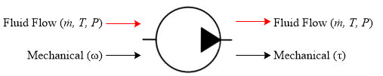

Figure 5.62. Hydraulic Engine Driven Pump Input and Output Energy Domains

The GUI of the hydraulic engine driven pump provides the ability to input multiple parameters in order to specify the operation and efficiency of the pump. Losses in the pump are calculated used the Hagen-Poiseuille Coefficient which require several nominal values of the fluid flow through the pump. The pump’s calculations do not have a large sensitivity to the values, but their relative magnitude should be accurate.

Table 5.13. Hydraulic Engine Driven Pump Graphical User Interface Inputs

|  |  |  |  |
| --- | --- | --- | --- |
| **Tab Name** | **Input** | **Units** | **Description** |
| General | Fixed Displacement | cm3/rev | The volume of fluid moved by the pump during each revolution (the theoretical max). |
| Mechanical Efficiency | % | Overall mechanical efficiency of the pump. |
| Volumetric efficiency | % | The ratio of actual flow out of the pump to the theoretical flow out of the pump. |
| Hagen-Poiseuille Coefficient | Nominal Fluid Temperature | °C | Nominal temperature of the hydraulic fluid flowing through the pump. |
| Nominal Angular Velocity | rad/s | Nominal angular velocity of the hydraulic pump shaft. |
| Nominal Pressure Differential | kPa | Nominal pressure differential of the fluid across the pump. |

#### Simulink Model

The Simulink model for the hydraulic engine driven pump is displayed in Figure 5.63. The GUI is shown in Figure 5.64 and Figure 5.65. A top level diagram of the Simulink model is shown in Figure 5.66.

|  |
| --- |
|  |
| Figure 5.63. Hydraulic Engine  Driven Pump Simulink Model |

|  |  |
| --- | --- |
|  |  |
| Figure 5.64. Hydraulic Engine Driven Pump General GUI | Figure 5.65. Hydraulic Engine Driven Pump Hagen-Poiseuille Coefficient GUI |

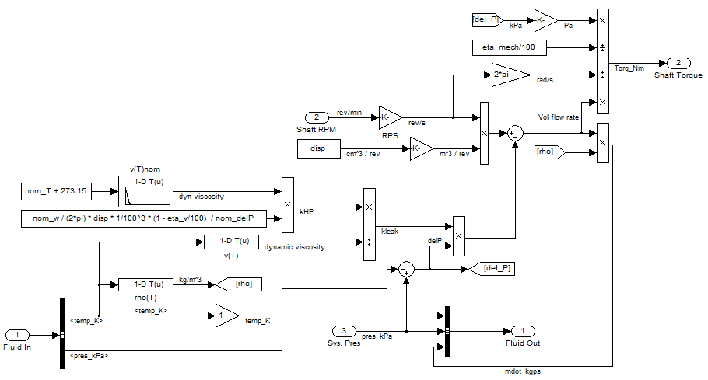

Figure 5.66. Hydraulic Engine Driven Pump Top-Level Simulink Diagram

### Fluid Reservoir

The fluid reservoir serves as a tank for storing excess hydraulic fluid. The reservoir is fed by returning hydraulic fluid and feeds the engine driven pump. Currently the fluid reservoir tracks the time dependent mass and temperature of the hydraulic fluid in the tank. In version of the PowerFlow toolset, the reservoir is pressurized with bleed air from the engine.

#### Mathematical Model

The mathematical model of the fluid reservoir is based upon first principles. The mass of the fluid in the reservoir is calculated as,

|  |  |  |
| --- | --- | --- |
|  |  | 5.4.5 |

where  is the flow rate of the hydraulic fluid and the subscripts denote into and out of the reservoir.

The rate of change in the reservoir fluid temperature is determined as a function the flow rate and temperature of the flow in and the fluid mass,

|  |  |  |
| --- | --- | --- |
|  |  | 5.4.6 |

where the  is the temperature of the fluid flow into the reservoir and  is the temperature of the fluid in the tank.

The rate of change in the air pressure of the reservoir is determined using input bleed air properties and mass of the air in the tank,

|  |  |  |
| --- | --- | --- |
|  |  | 5.4.7 |

where  is the flow rate of bleed air into the reservoir,  is the universal gas constant for air,  is the temperature of the bleed air into the reservoir,  is the compressibility factor for air, and is the volume of the air in the reservoir. The volume of the air changes in time with respect to how much volume of hydraulic fluid is within the reservoir.

#### Component Inputs and Outputs

The first input to the hydraulic fluid reservoir is the fluid bus containing flow rate, temperature, and pressure variables of the bleed air which comes from the engine. The second input is the bypass return from the bypass or pressure release valve. This input is also a fluid bus containing the previously mentioned variables. The mass flow rate flowing out of the fluid reservoir is the third input which typically is calculated by the upstream engine driven pump. The engine driven pump provides this mass flow rate as an output. The final input is the mass flow rate of the returning hydraulic fluid from the loads. In version of the PowerFlow toolset there is no thermal component to the hydraulic loads, so temperature changes in the hydraulic fluid flow are not captured between the pump and loads.

Output signals include a bleed air flow rate demand and output fluid flow bus. The bleed air demand is determined as a function of air pressure in the fluid reservoir and the desired set point.

The GUI of the hydraulic fluid reservoir provides the ability to input multiple parameters in order to specify the geometry and operation of the reservoir.

Losses in the pump are calculated used the Hagen-Poiseuille Coefficient which require several nominal values of the fluid flow through the pump. The pump’s calculations do not have a large sensitivity to the values, but their relative magnitude should be accurate.

Table 5.14. Hydraulic Fluid Reservoir Graphical User Interface Inputs

|  |  |  |  |
| --- | --- | --- | --- |
| **Tab Name** | **Input** | **Units** | **Description** |
| General | Fixed Reservoir Volume | m3 | The volume of the reservoir. Used in the calculation of air to fluid volume ratio. |
| Max Bleed Air Supply Rate | kg/s | Maximum bleed air flow rate that is capable of being supplied to the reservoir. |
| Initial Conditions | Initial Fluid Temperature | K | Initial fluid temperature of the hydraulic fluid in the reservoir in Kelvin. |
| Initial Air Pressure | kPa | Initial air pressure of the reservoir in kilopascals. |
| Initial Fluid Mass | kg | Initial mass of the hydraulic fluid in the reservoir. There is not check between the mass and available volume in the reservoir. |

#### Simulink Model

The Simulink model for the hydraulic reservoir is displayed in Figure 5.67. The GUI is shown in Figure 5.68 and Figure 5.69. A top level diagram of the Simulink model is shown in Figure 5.70.

|  |
| --- |
|  |
| Figure 5.67. Hydraulic Fluid  Reservoir Simulink Model |

|  |  |
| --- | --- |
|  |  |
| Figure 5.68. Hydraulic Fluid Reservoir General GUI | Figure 5.69. Hydraulic Fluid Reservoir Initial Conditions GUI |

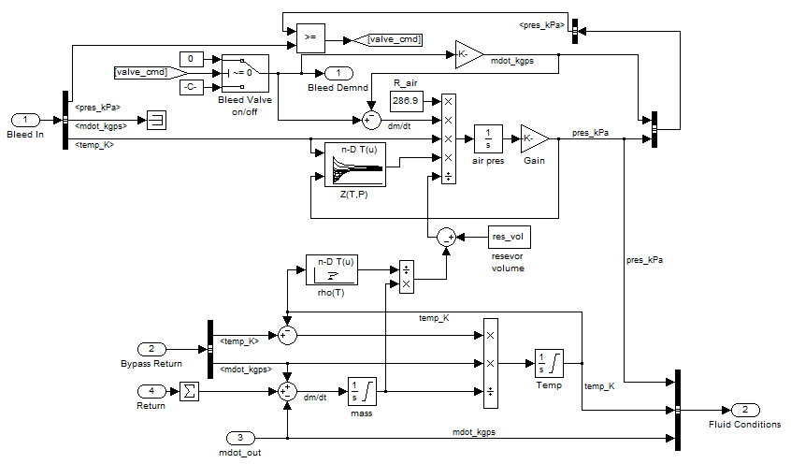

Figure 5.70 Hydraulic Fluid Reservoir Top-Level Simulink Diagram

### Bypass Valve

The bypass valve is responsible for routing flow to the hydraulic actuators/loads or bypass the flow back to the fluid reservoir. The model requires two inputs: fluid flow in (typically from the pump) and required flow (as calculated by the hydraulic loads). The bypass valve then passes the required flow to the actuators/loads and returns the rest of the flow to the reservoir.

### Hydraulic Load

The hydraulic load model is reflective of mass flow rate through hydraulic actuators over the course of the mission profile. Dynamics of the actuators are not modeled as the power consumed by the actuators is a linear function of the mass flow rate through the actuators. As such, the hydraulic load model provides the user a selection of hydraulic loads which are located in a look up table and contain stochastic flow rates that are scaled appropriately for each mission phase.

#### Component Inputs and Outputs

The hydraulic load model takes a fluid input bus from the bypass valve and the flight phase from the mission profile. The outputs are the return flow rate of hydraulic fluid flow and the power consumed by the hydraulic load. The power is determined by,

|  |  |  |
| --- | --- | --- |
|  |  | 5.4.8 |

where  is the mass flow rate of hydraulic fluid through the actuator, is the pressure of the fluid, and is the density of the fluid.

#### Hydraulic Load .mat File

The mass flow rate through a hydraulic actuator is dependent upon the mission phase. For example, the elevator of an aircraft will see more hydraulic action during take-off, climb, and landing than it will for cruise. These trends are captured via a .mat file that is loaded into MATLAB’s workspace that is called by the hydraulic load model in order to populate a lookup table.

In version of the PowerFlow toolset the HydraulicLoad.mat file is included in the *PropertyTables* directory and is structured as shown in Figure 5.71.

Figure 5.71 Structure of Hydraulic Loads of the HydraulicLoad.mat File

Each of the loads is a 2D matrix with rows corresponding to the mission phase number and columns corresponding to time in 1 second increments. For details on the correlation of mission numbers and mission phase, refer to Section **Error! Reference source not found.**.

## Auxiliary Loads and Systems

Varying electrical power is demanded from various components such as the cabin loads, lighting loads and other electronic loads. The status signals for intermittent loads such as the taxi and landing lights are generated from the mission profile block. The status signals are combined with the electric power magnitude to provide the dynamic loading conditions on both the AC and DC subsystems of the electrical system. Other miscellaneous time-varying loads (for example, Avionics) can be configured in one of the following ways.

Define a statistical load with average power consumption in watts (W) and a variance parameter along with load value sampling interval in seconds (s).

Read from a user-defined .mat file with a structure field consisting of time samples and corresponding power load in watts.

The above options are provided in the dropdown dialog box obtained by double-clicking the ‘Loads’ block in the electrical system, as shown in Fig. 5.67. These varying loads are routed to the electrical system using sink-source block pairs and use the following signal names shown in Table 5.5.1 to denote the location of the loads in the AC or DC side.

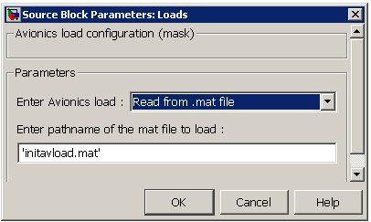 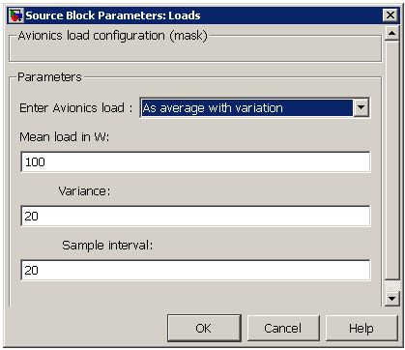

* 1. (b)

Figure 5.67 Two ways of configuring the miscellaneous dynamic loads (a) Input from mat file (b) Input as a statistical load

In version of the PowerFlow toolset the initavload mat file, as indicated in Fig. 5.67, is included in the *Missionprofile* directory and is structured as shown in Figure 5.68.

Figure 5.68 Structure of the miscellaneous load in the workspace

**Table 5.115. Signal names for electrical load identification**

|  |  |
| --- | --- |
| **Location of load**  Cockpit and miscellaneous stochastic loads  Cabin  Right Wing  Left Wing | **Load signal name**  DC\_Load1  DC\_Load2  AC\_Load1  AC\_Load2 |

# System Modeling

The system being model is that of a Boeing 737 that consists of five main systems: the engine systems, the environmental control system, the fuel and oil system, the electrical system, and the hydraulics system.

## Engines System

For the Boeing 737, there are two engines that need to be modeled. The input signals to each of the engines are Electrical (torque), Mission Profile (temperature and pressure), Fuel (mass flow rate), Oil (mass flow rate, pressure, and torque), and Total Bleed Air (mass flow rate). There is a single output signal for each engine that consists of spool speeds, fuel mass flow rate and pressure, total bleed air (mass flow rate, temperature, and pressure), and oil (mass flow rate, temperature, and pressure) combined together.

### Engine Output Signal

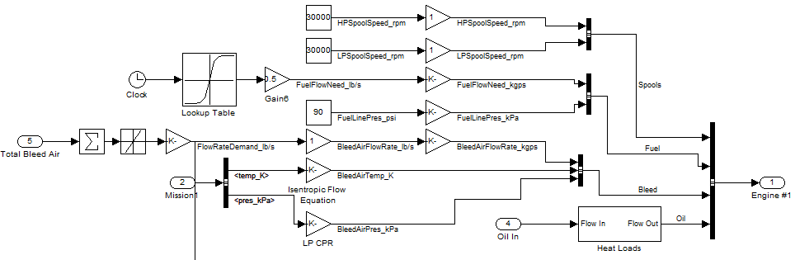

Figure . Example of Engine signal model

As mentioned earlier the engine output signal consists of different information as seen in Figure 6.1. The high and low spool speeds are defined and combined into one signal. The fuel mass flow rate signal starts with a clock block linked to a lookup table. The lookup table output signal is adjusted using a gain block and then converted into the units of kg/sec. The fuel line pressure is defined by the user and is combined with the fuel mass flow rate before to form a fuel signal. The total bleed air and mission (temperature and pressure) signals are inputs into the engine and define the bleed air signal. By using gain blocks they are converted into the appropriate units and then combined to form the bleed air signal. The oil signal is also an input to the engine and is sent into to the heat load block. The output is the oil signal that consists of temperature, mass flow rate, pressure, and energy density. All of these signals are combined to form the output engine signal.

### NPSS Model

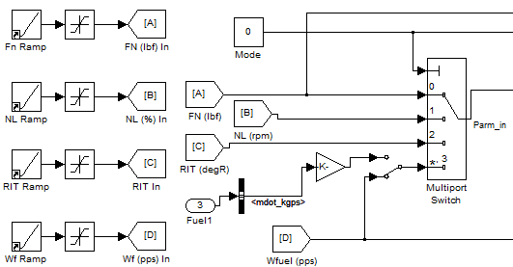

Figure . Initialization of the NPSS model: Multiport information switch

The other component of the engines is the NPSS model. At first a mode for the different types of inputs is defined by 0-Runs to a thrust, 1-Runs to a LP Shaft RPM, 2-Runs to an RIT in degrees R, or 3-Runs to a fuel flow rate in pps. Each of these are sent into a multiport switch that outputs the selected mode as seen in Figure 6.2.

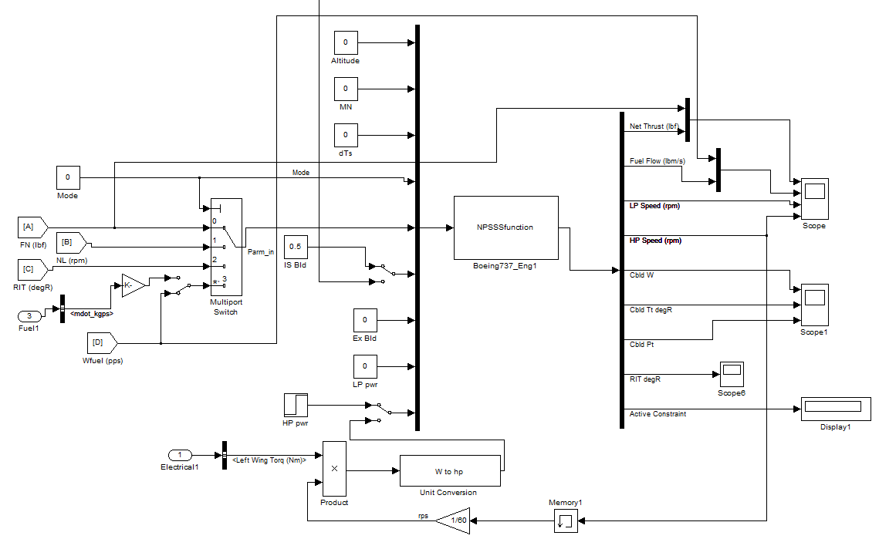

Figure . NPSS Boeing 737 model

The signal that goes into the NPSSSfunction as seen in Figure 6.3 consists of the altitude, the mach number, the change in temperature, the selected mode and its value, the total bleed air, excess bleed air, the low pressure power, and the high pressure power. The NPSSSfunction takes in this data as a single signal and outputs a single signal that consists of the net thrust, the fuel flow rate, the low pressure speed, high pressure speed, the cabin power, temperature, and pressure, the temperature, and some constraint. The high pressure speed is multiplied by the torque to get the power that is fed back into the NPSSSfunction.

## Environment Control System

The environment control system takes in signals from both of the engines, the mission profile, the cabin conditions, and a control and outputs fan flow signal (that includes temperature and mass flow rate) and a fan power signal that is sent to the electrical system.

### Overall System

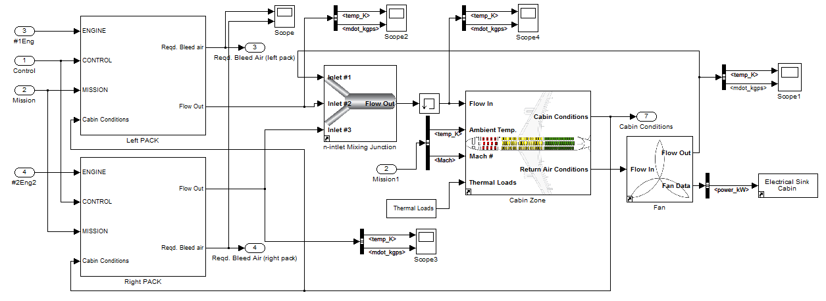

Figure . Environment Control System

The environmental control system as seen in Figure 6.4 takes in signals from the both engines, the mission profile, the cabin conditions, and a control. Each of the signals goes into the left and right air recycled PACK's. The output signals to the PACK's are required bleed air signal (mass flow rate), and flow out signal (mass flow rate, temperature, and pressure). The required bleed air signals from the left and right PACK are output signals for the ECS. The flow out signals for the PACK's are fed into an n-inlet mixing junction with a recycled flow out signal defined later. These signals are combined into one flow signal which can be saved in a memory block.

This signal is sent into a cabin zone component. The cabin zone component takes in that flow signal, ambient temperature and mach number decomposed from the mission profile input signal, and the thermal loads signal. The cabin zone component outputs are the cabin conditions (output signal for the ECS system), and return air conditions. The cabin conditions are put back into the left and right PACK. The return air conditions is sent into the fan component. The fan outputs are a flow signal that is put back into the n-inlet mixing junction and an output power signal semt to the electrical system.

### PACK Components

#### Distribution of Bleed Air

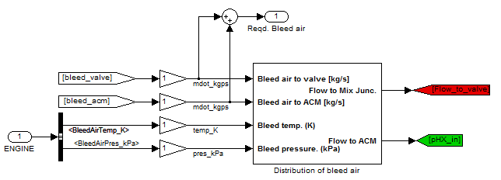

Figure . PACK Bleed air distribution component

The first component of the PACK handle the bleed air distribution, Figure 6.5, by taking in the engine signal and decomposing it into the bleed air temperature and bleed air pressure. The bleed air valve and bleed air cycle machine mass flow rates are fed into an addition block to form the required bleed air output signal. All of these signals are be put into a distribution of bleed air component.

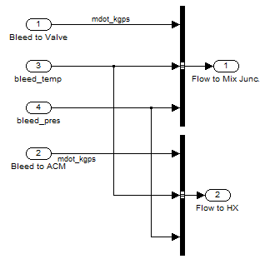

Figure . Distribution of bleed air block

The distribution of bleed air block combines each of the input signals as seen in Figure 6.6 into two output signals, flow to the mixing junction sent to the valve and flow to the heat exchanger.

#### Control, Mach Number, and Temperature

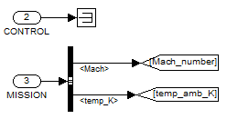

Figure . PACK Control and Mission signals

The control signal can be just connected to a termination block. The mission profile signal must be decomposed and tagged into the mach number and the ambient temperature.

#### Primary Heat Exchanger

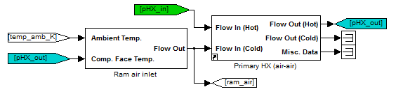

Figure . Primary Heat Exchanger subsystem model

The primary heat exchanger takes in the ambient temperature and compares it to the temperature of primary heat exchanger, Figure 6.8. Both of these temperature signals are sent into the Ram air inlet component where the output is a flow signal, tagged ram air, that includes temperature, pressure and mass flow rate. This flow signal is the cold input for the primary heat exchanger where the hot input was defined by the distribution of bleed air component. The output to the primary heat exchanger is tagged the hot flow from the primary heat exchanger. This was used eariler.

#### Compressor and Turbine

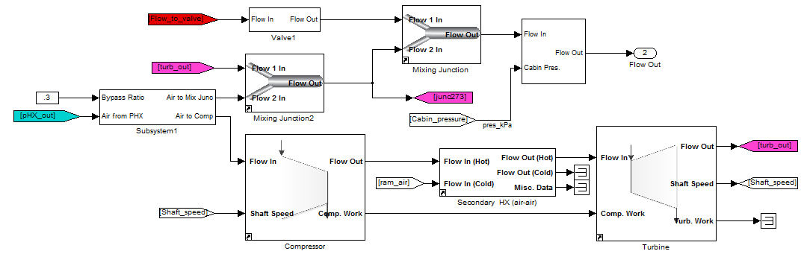

Figure . PACK compressor and turbine subsystem model

The hot flow from primary heat exchanger is also used in the compressor and turbine components as seen in Figure 6.9. This signal and a bypass ratio are fed into a distribution component which distributes the airflow to the mixing junction and to the compressor. The airflow to the mixing junction and the flow from the turbine defined later are sent to a mixing junction block which outputs the junction signal (junc273). The flow to the value is sent into a valve block. Both of these signals, junction and the flow out of the valve, are sent into another mixing junction. The output of this mixing junction and the cabin pressure are combined together to form the flow out signal.

The airflow from distribution block is also sent to the compressor along with the shaft speed to get a compressor flow out signal and a compressor work signal. The compressor flow out signal (hot) and the ram air signal mentioned in the primary heat exchanger (cold) are sent to the secondary heat exchanger. In the secondary heat exchanger, the output is the flow out (hot) signal which is sent to a turbine. The secondary heat exchanger flow out (cold) and the misc data are not needed. The turbine takes in the secondary heat exchanger flow out (hot) signal and the compressor work signal to output a flow signal to the turbine that was used earlier, the shaft speed, and a turbine work signal.

#### PID Temperature Control

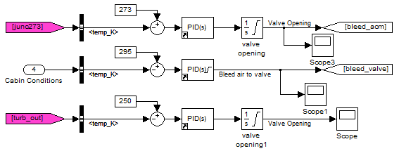

Figure . PID temperature control subsystem model

The temperatures of the junction (junc273) from the compressor and turbine, cabin from the input of the ECS system, and turbine from the compressor and turbine are put into a PID controllers as seen in Figure 6.10. This is done to control the each of the temperatures. The outputs are the bleed air temperature to the air cycle machine and the bleed air temperature of the valve.

## Fuel and Oil System

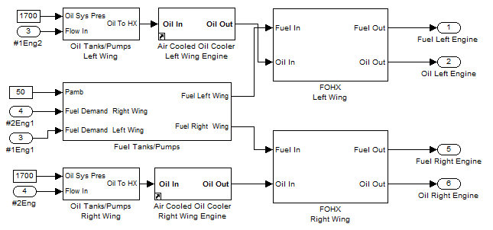

Figure . Fuel and Oil system model

The fuel and oil subsystem seen in Figure 6.11 consists of oil and fuel tanks and pumps, oil coolers and fuel and oil heat exchangers. The input signals are from the engines while the outputs are fuel and oil flow signals to the engines. The right and left oil tank/pump output signals are sent to their own air cooled oil cooler component. The left (right) oil output signal and left (right) fuel wing output signal are sent to the fuel and oil heat exchanger (FOHX) where the output signal is fuel to the left (right) engine and oil to the left (right) engine.

### Oil Tank and Pump Subsystem

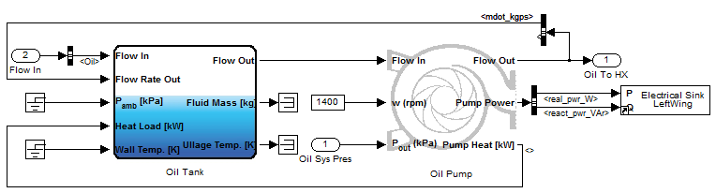

Figure . Oil Tank and Pump subsystem model

The oil tanks and pumps are defined by oil tank and oil pump components as seen in Figure 6.12. The oil tank takes in a flow signal from the engine (mass flow rate and temperature), a recycled flow rate signal defined later, an ambient pressure, a recycled heat load defined later, and the wall temperature. The major output for the oil tank is the flow signal which is fed into the oil pump. The other outputs are fluid mass and ullage temperature which don't need to be used.

The oil pump also takes in the speed of the pump and the oil pressure, which is an input to this component. The output to the oil pump is a flow signal that is sent to the oil heat exchanger. This signal is also composed into mass flow rate and sent back to the oil tank as mentioned previously. The other outputs to the oil pump are the pump power, which is sent to the electrical system, and a pump heat signal sent back to the oil tank as mentioned previously.

### Fuel Tank and Pump Subsystem

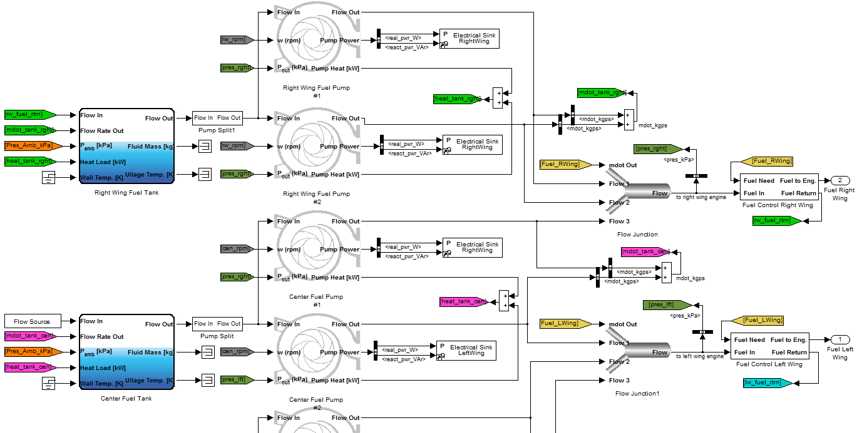

Figure . Fuel tank and pump subsystem model

The fuel tank and pumps are composed of three fuel tanks (right, center, and left), six fuel pumps, and flow junctions as seen in Figure 6.13. The fuel tanks takes in the flow, mass flow rate, ambient pressure, heat load, and wall temperature from each fuel tank they are defined for. Each fuel tank outputs a flow signal, which is sent to two fuel pumps (for each fuel tank). The fuel pump take this signal along with the pump speed and pressure to output the a flow signal, the pump power (which is sent to the electrical system), and the pump heat (which are combined to formed the tank heat).

The output flow signals for each pump is decomposed and added together to get the total mass flow rate for that section (right, center, or left). Also, the output flow signals for each of the pumps along with one of the output flow signals from the center fuel pump are sent to a n-inlet mixing junction. The n-inlet mixing junction output signal is decomposed to make the pressure signal and also sent to a fuel control block where the outputs are the fuel flow to the engine and the fuel flow that is returned to the tank.

## Electrical System

The electrical subsystem takes in signals from the left engine, right engine, control, and mission to output an electrical signal. The electrical signal is composed of torques from the left wing generator, right wing generator, and APU generator.

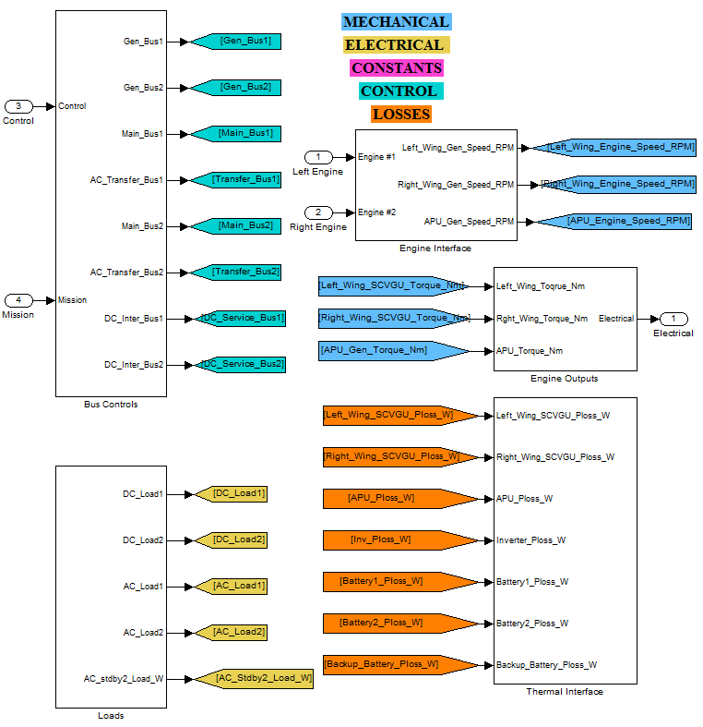

Figure . Electrical System tags

Each bus and load is indicated by using a specific tag as seen in Figure 6.14. The engine signals are broken down to left wing, right wing, and APU generator speeds. Each of the engine torques are combined to form a the electrical signal. Each of the thermal components is sent to the thermal subsystem.



Figure . Initialization clock

An important thing to note is that the generator need some time to run before loading. A clock connected to an inequality block must be created. The output signal was tagged enable. After 50 seconds, everything would be enabled. The electrical subsystem can be divided into three components, the AC system, the DC system, and the connection between the two systems.

### AC Subsystem

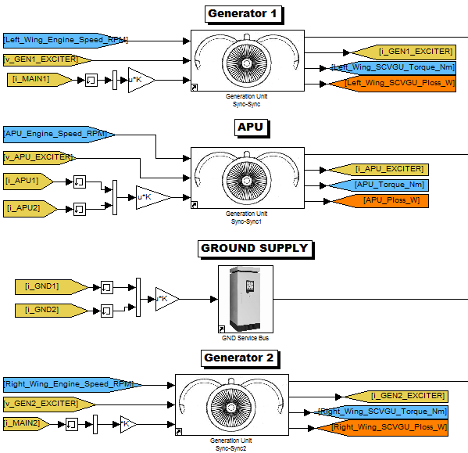

Figure . AC power generation

The AC system consists of the generators, the APU, the ground supply, the AC buses and AC loads. There are two generators, right and left, and the APU that take in the engine speed, the battery voltage, and the AC current. The output for each of these components is AC voltage, battery current, engine torque, and the power loss. The ground supply just takes in AC current and outputs AC voltage.

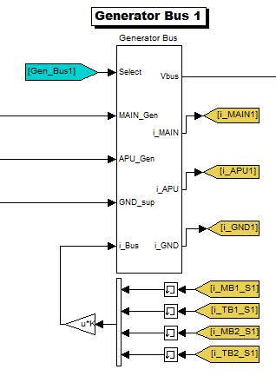

Figure . Generator Bus model

Each of the main generators is connected to a generator bus, Figure 6.17, that takes in an AC voltages from each of the AC power supplies. The inputs to the generator bus include the tag to define the bus, the AC voltage signal from the same number generator, the AC voltage signal from the APU, the AC voltage signal from the ground supply, and the AC current from each of the loads. The output signals of the generator bus are AC voltage, and the AC currents from the main, the APU and the ground.

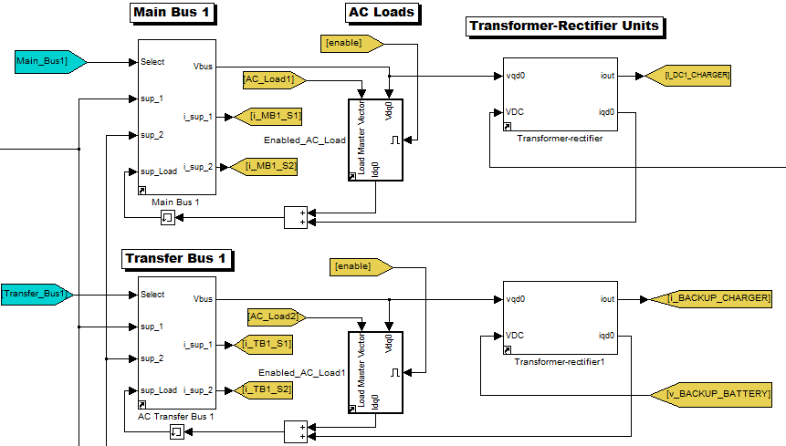

Figure . Main and Transfer Bus with AC load

The generator bus AC voltage is sent to a main bus and transfer bus that handles the AC loads and the transformer rectifier for the DC components. The main bus and the transfer bus as seen in Figure 6.18 takes in a tag to define the bus, an AC voltage signal from its generator bus, an AC voltage signal from the other generator bus, and an AC current from the AC loads. The outputs to the main and transfer bus are an AC voltage, and AC currents, which are used by the generator bus.

The voltage signal from the main buses are delivered to the AC loads and the transformer-rectifier defined later. The AC loads takes in a AC load signal (that consists of real power, reactive power, and AC current), AC voltage, and the enable start signal. The output to the AC load is the AC current that is fed back to the main bus and transfer bus.

### DC Subsystem

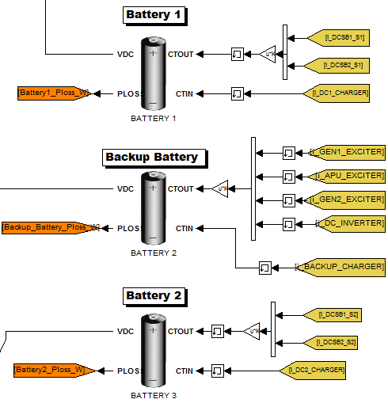

Figure . DC power supply model

The power supply to the DC system consists of two main batteries and one backup battery. The inputs to the batteries are DC currents out of the batteries and DC currents into the batteries as seen in Figure 6.19. The outputs to the battery are voltages sent to the DC buses and power losses sent to the thermal system.

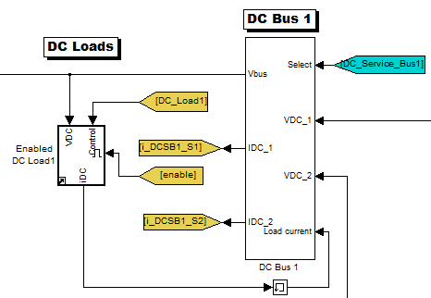

Figure . DC Bus and DC loads

For each of the main batteries there is a DC bus that takes in a tag to define the bus, the DC voltage from its battery, the voltage signal from the backup battery, and the DC load current as seen in Figure 6.20. The output for the DC bus is the DC voltage, and the DC bus currents. The DC voltage signal is used in the DC load along with a control signal (power and current), and the enable start signal. The output is a DC current that is sent back to the DC bus.

### AC-DC Connections

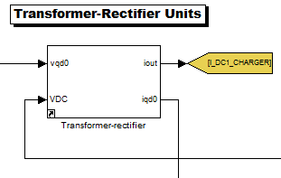

Figure . Transformer-Rectifier Unit model

The voltage signals from the AC main and DC buses are sent to their own transformer-rectifier. The outputs are DC current and AC current, which is fed back (with the addition of the AC loads current signal) to their main bus. The transfer buses are also connected the same way to a transformer-rectifier unit, but the DC voltage signal is taken from the backup battery and the output DC current is sent to the backup charger.

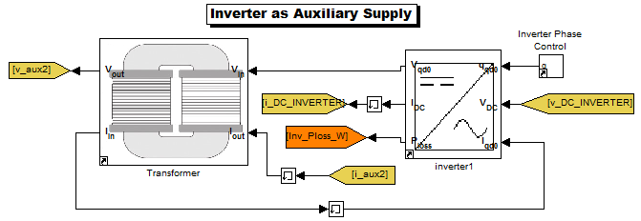

Figure . Inverter model

The other component that links the AC and DC systems is the inverter. The inverter takes in the AC phase, DC voltage, and AC current defined later while outputting AC voltage, DC current, and power loss (that is sent back to the thermal system). The AC voltage signal and an AC current signal are sent to the transformer that outputs an AC voltage and AC current that is used by the inverter before.

## Hydraulics System

The hydraulics system consists of section that indicates which phase of flight the airplane is in, and the right and left wing hydraulics. The hydraulic system takes in signals from the flight phase, the bleed air from the left wing, and the bleed air from the right wing. The output signals to the hydraulic system are a flight phase tag, the bleed air demand for the left and right wing, and the return system.

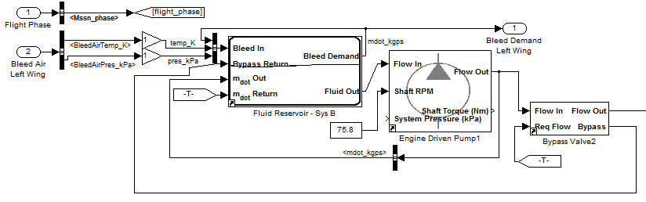

Figure . Hydraulic System model Part 1

The flight phase is decomposed to a flight\_phase tag. The bleed air left wing and right wing are the same with different outputs (left or right and sysA or sysB). The model for the left wing is shown in Figure 6.23 and Figure 6.24. The model for the right wing is the same but with the right wing inputs and outputs. Looking at the bleed air for the left wing, the bleed air signal is decomposed into the bleed air temperature and bleed air pressure. These signals along with a mass flow rate defined later are combined to form an air flow signal for the fluid reservoir (Sys A or Sys B for the right wing).

The fluid reservoir also takes in signals from the bypass return defined later, mass flow rate defined later and the return system mass flow rate. One of the outputs to the fluid reservoir is the bleed air mass flow rate that is sent back to the fluid reservoir and the outputted from the hydraulic system. The other output is a fluid out signal. This signal along with the shaft speed is sent to the engine driven pump which outputs the flow signal that is sent back to the fluid reservoir and bypass valve.

The bypass valve also takes in the required flow. The outputs are a flow signal that is sent to each of the components and a bypass return signal that is put back to the fluid reservoir.

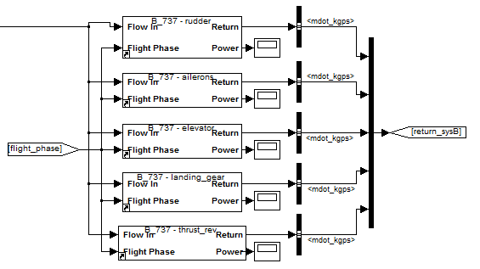

Figure . Hydraulic System model Part 2

The bypass valve flow signal and flight phase are sent to the Boeing 737 rudder, ailerons, elevator, landing gear, and thrust blocks as seen in Figure 6.24. The outputs for each of these blocks are mass flow rates, which are coupled into one return signal.

# References

1. P. C. Krause, O. Wasynczuk and S. D. Sudhoff. *Analysis of Electric Machinery and Drive Systems.* Piscataway, NJ: IEEE Press, 2002.
2. P. W. Sauer and M. A. Pai. *Power System Dynamics and Stability*: Prentice Hall Press, 1998.
3. R. C. Kroeze and P. T. Krein, “Electrical battery model for use in dynamic electric vehicle simulations," *IEEE* *Power Electronics Specialists Conference PESC 2008,* pp.1336-1342, 15-19 June 2008.
4. M. H. Teruel, C.Y. Nakashima and P. Paglione, " Rectangular offset strip-fin heat exchanger lumped parameters dynamic model,” 3rd CTA-DLR Workshop on Data Analysis & Flight Control. September 14-16, 2009, S. J. Campos, SP, Brazil
5. M. Jung, R. G. Ford, K. Glover, N. Collings, U. Christen and M. J. Watts, “Parameterization and Transient Validation of a Variable Geometry Turbocharger for Mean-Value Modeling at Low and Medium Speed-Load Points,” SAE Technical Paper 2002-01-2729, 2002.